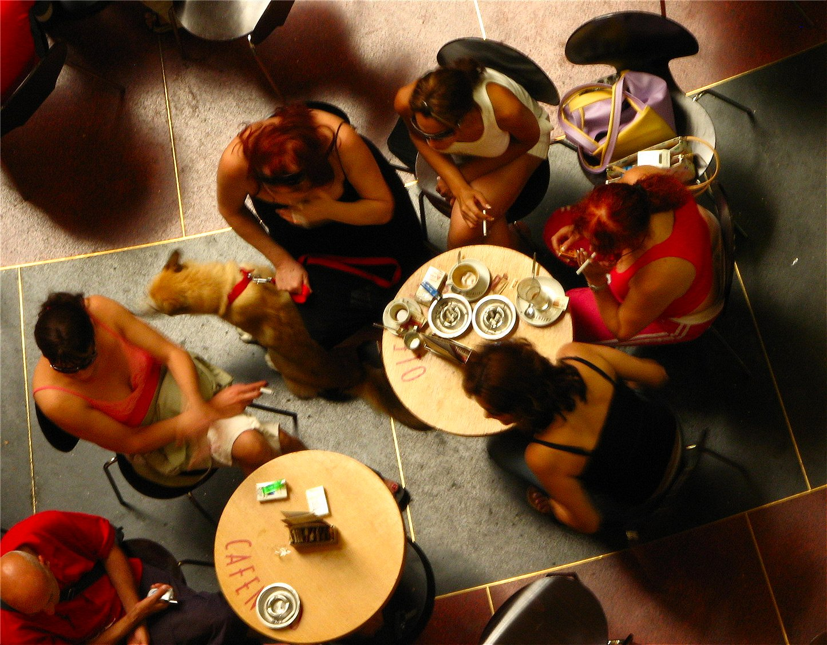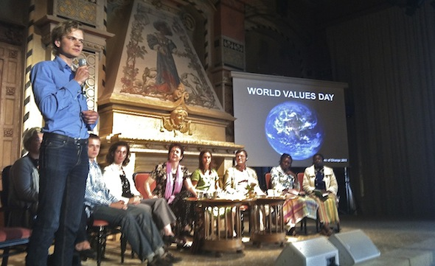

**Vision**

We encourage all future leaders to find their own core values in order to improve decision-making on both a personal and a professional level. We aim to achieve this through the Values Day.The Values Day is an experience-orientated day for students, alumni as well as the public. Furthermore, it is our hope to engage renowned leadership experts and organization leaders to contribute with their time and knowledge.

**Background**

All individuals of all cultures have a personal set of core values; these in turn are the basis for our actions and the perception of our surroundings. Open dialog concerning values is a prerequisite for effective decision-making on an individual, professional and societal level. We want to encourage people to engage in open dialog on the topic of values and their importance in society.

The Values Day took place, for the first time, as a pilot-project the 18th of September 2011 in Stockholm. It was vastly appreciated and we wish now to expand the concept to KTH. A project team composed of KTH students is arranging to host a Values Day on campus and a preliminary date is set to the 22nd of September 2012.

**Leadership as a theme**

We wish to host a day that is both interactive and timeless but with a distinct focus. We therefore plan to have “Leadership” as the topic for the first Values Day at KTH. The participants are encouraged to choose a workshop presenting one facet of leadership: *Self leadership, Leadership within groups, Leadership out of a organizational perspective and Leadership from a Global perspective.*

### The Values Day aims to offer an experience-orientated day concerning the topic of values for students, alumni as well as the general public.The day will take place the 22nd of September 2012 at KTH.

Our guiding Values are openness, inspiration and longevity

**Worldcafé and Conclusion**

After the workshops, an opportunity to share thoughts and experiences from the day is given. World Café is an organized form of sharing influenced by speed-dating. It is a way of creating an all-round perspective of the day by summing up the impressions of several participants. The day is concluded with a common assembly on the Sing Sing floor.

**Workshop II – Leadership**

The Participants may now choose from among four different workshops that discuss different aspects of the leadership role. An opportunity to ponder on this facet of leadership and how values can be applied to it.

**Introduction and Keynote Speech**

A common introduction to the topic of Values and an inspirational speech sets the tone for the day.

**Lunch**

A hot lunch is served on the Sing Sing floor. Participants are now able to mingle and share their experiences from the morning session.

**Workshop I – IntroductiontoValues**

The Participants are given a basic set of tools to help discover and reflect upon their own values and understand the connection to decision-making.

### Värderingsdagen 2012, upplägg