Hack – Integral Leadership
Setup
Title:
Integral Leadership – a comprehensive approach for developing leaders who can promote fundamental renovation in organization management and nurture the foundations for transforming capitalism

Summary:
Integral Leadership development model (by Unipaz) was built to allow Human Beings transformation into leaders for challenges of the twenty-first century. It prepares people to use their entirety, body, mind, soul and spirit. It makes wide use of science, but also employs other sources of knowledge. Primary results are stunning.

Up to 3 moonshots
- Focus the work of management on a higher purpose
- Rethink the philosophical foundations of management
- Redefine the work of leadership

Problem:

The world has been facing significant and rapid transformations while our economic and political systems have been failing to achieve the illuminist principles of liberty, equality and fraternity. Whilst socialism and communism have restricted democracy and have been unsuccessful to stimulate effectiveness, capitalism struggles to be accepted as an ideal economic system.

Concurrently, we can observe the significant progresses in the area of science with intense specialization of knowledge where people are becoming more knowledgeable in fewer subject matters. As science prevails as the standard way of thinking, other sources of knowledge such as arts, philosophy and spiritual traditions were put aside in the intellectual development of the individual.

Such disconnection creates an important gap in the basis on which our leaders are formed which brings substantial impacts to our organizations.
The Integral Leadership challenges this mentality and offers means to overcome these dilemmas by developing leaders who can profoundly impact organizations and provide a prosper outlook to capitalism.

This innovative approach to leadership proposes the synthesis concepts from a political, economic and social perspective as well as in the domains of Knowledge and Thought. It is a mechanism that pursues the integration of the conflicts above mentioned promoting “effectiveness with affection”, “liberty, equality and fraternity”, and “science with consciousness”.

Figure 1: The Integral Enterprise arising from an integration of contradictions

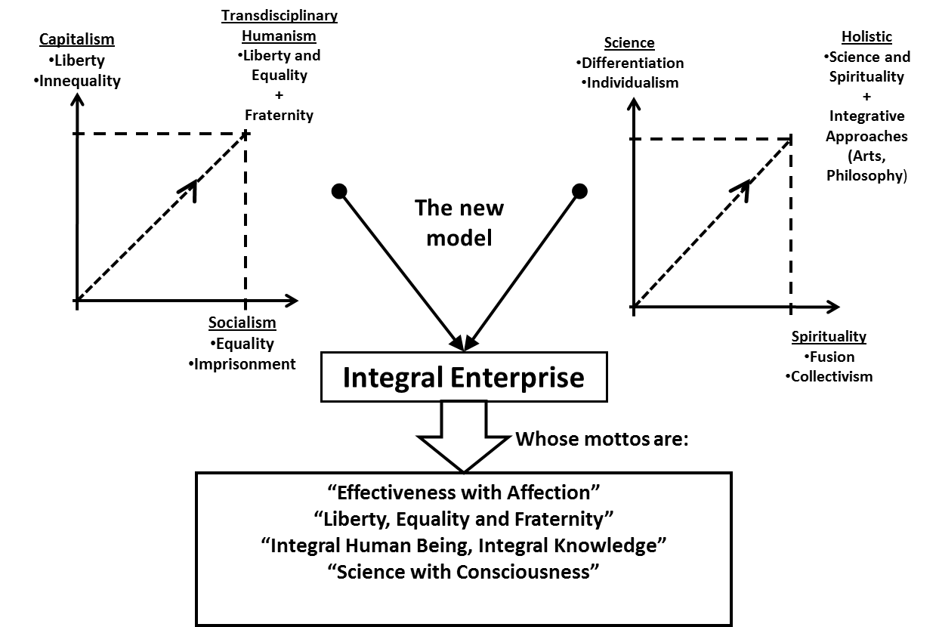

Sketch
Solution:
The model for Integral Leadership was inspired on the principles of the Transdisciplinary (this terminology was first created by Jean Piaget) philosophy which was structured by Basarab Nicolescu (Romanian theoretical physicist and co-founder of Transdisciplinary study group at UNESCO), the Holistic formation developed by Unipaz, founded by Pierre Weil (French psychologist and educator), and the most renowned management theories and practices connected by Wanderlei Passarella (Brazilian Engineer, Economist, MBA with a successful track record as CEO of large corporations).

Based on the convergence of these fundamentals, Unipaz has been developing educational programs to disseminate the holistic learning and to allow individuals to reach their highest potentials as human beings, encouraging their engagement in the construction of an improved society and sustainable ecosystem, and where interpersonal relations are oriented based on a clear understanding of tolerance and fraternity.

Recently, Unipaz has initiated the Integral Leadership program where the principles of the holistic education come together with the organizational environment in order to fulfill the gap in the development of new leaders who will be capable of transforming organizations towards the demands of the 21st century, and will be able to establish management practices that are ecologically sustainable, socially responsible and economically viable. Within the context of this program was where the model for Integral Leadership was structured.

A model for Integral Leadership

Basic attributes for the Leader
Integral Leader emerges from the Integral Human Being, who is an individual that makes use of a variety of sources of knowledge to comprehend him or herself, others and the world. He or she acknowledges the importance of science and studies it deeply; and, at the same time, understands its limits. For this reason the Integral Human Being pursues knowledge not only in science, but also in arts, philosophy and human knowledge traditions. Through the holistic view, and making use of multiples intelligences (Intellectual, Physical, Emotional and Spiritual), the Integral Human Being may integrate and amplify this knowledge; as Einstein said: “There is no logical path to the discovery of the laws of the universe - the only way is intuition”.

In general, we can say that leaders are supposed to perform changes from stage “A” to stage “B”. Wherever there is stability, predictability, inertia, there should not be a need for a leader.

Figure 2: The Leadership Journey: to conduct from “A” to “B”
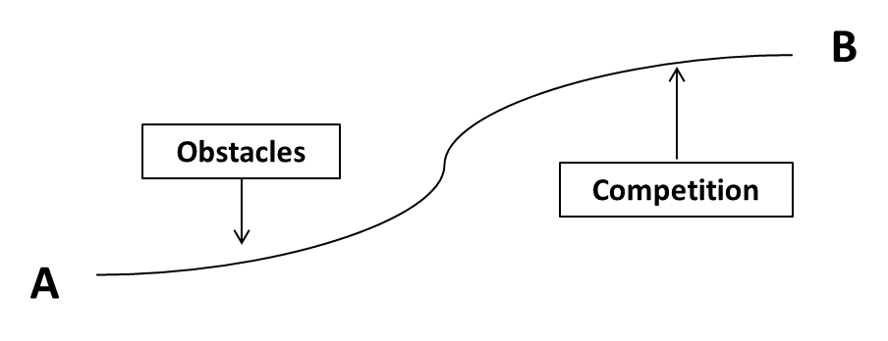
Therefore, leaders need vision to conduct organizations from “A” to “B”, surpassing obstacles and competitors. They have to create a meaningful purpose to what has to be done, and it has to unify people for its nobleness and usefulness of what is being done together.

Leaders need passion to involve the ones around him and that is the best he can offer them to motivate themselves, as motivation should come from the inside of each individual. At the same time, the leader has to be an example of integrity in the small details as well as in big decisions, since that is how people will build trust on him. And without trust, there is no leadership. There might be, at most, a relationship of command and control, but not the leadership in the way we define it.

In addition, leaders should demonstrate curiosity and innovative spirit, being able to create new ways to go from “A” to “B”. This entrepreneurship ability and the willingness to innovate allow the leader to be capable of pursuing different corporate strategies, alternative product lines and new businesses, original management systems and other innovation that might become necessary. Leaders create the future instead of waiting for it to arrive. They have the innovative ability to create and recreate their businesses and new ventures both in the short and the long term, so that they achieve a perennial path, which is one of the main objectives of corporations.

There are many other important leadership skills described in many business administration books, but, in our view, these are the minimum attributes which are necessary to build the foundations for the model of Integral Leadership.

The “Triple-Focus”

Throughout years of leadership study, two main focuses of activities became very clear and have been described in many business administration books. These two focusses are the tasks (results) and people (relationships). Blake and Mouton were the ones who have developed and elaborated on them, but many others reaffirmed them.

Focus on tasks and results means that one of the main activities of leadership is to ensure that the important tasks of his business are being performed and delivers results. This is the main objective and one can not loose priority to it. To understand the main objectives and targets of the company, how to distribute them and how to ensure they are implemented is essential in any leadership. Therefore, focus on tasks should be placed on very high priority.

Focus on people is the counterpart of the focus on tasks. While focus on tasks is far more concerned in what they do and how they do it, focus on people emphasizes on allowing tasks, goals and objectives to be achieved while maintaining an environment of high respect, safety, and concern for the human being. It means understanding that an organization exists not only to achieve results, as broad as than they can be defined, but also to allow the human development of those who are involved.

Organizations where tasks are the only or prevailing focus somehow become autocratic and less human. If only tasks and results matter, then you can accept that "the ends justify the means". Disrespect and “command and control” become effective means for getting what you want. But the point is that this type of conduct has two disastrous consequences: firstly, it is not ethically responsible, has no support in view of the common good. Secondly, there is evidence that organizations that practice this focus may even get splendid financial results in the short and medium term, but in the long term, they can become a time bomb. Where do confidence and motivation reside? Where is the real sum of effort where one plus one is more than two?

Therefore, we can only think of leadership evolution when these two focusses are simultaneously pursued. Focus on tasks (results) and focus on people (relationships). This conjunction of the two focusses has been advocated for some time and we are currently in a process of understanding this dual focus as the "participative leadership". Figure 3 illustrates this trend.

Figure 3: Trend in leadership focus

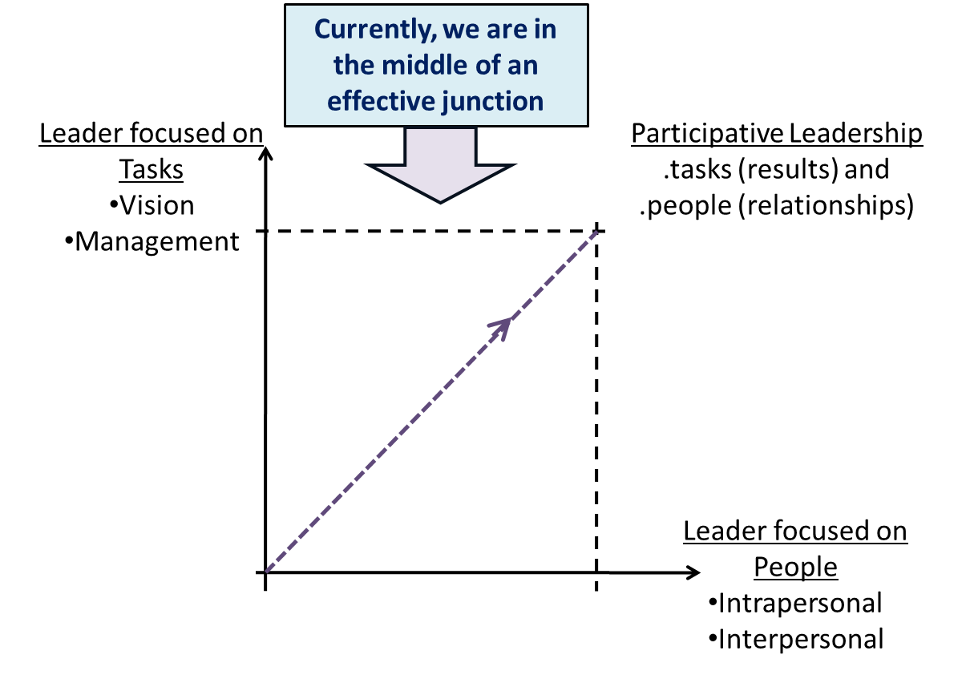

But the integral leadership does not only consider the tasks and people. The integral leadership, strives to meet the major challenges of the twenty-first century, also considers the full potential of man (the man himself), their relations with their peers, and their relations with nature and the cosmos. So in order to exist, integral leadership brings a third focus: focus on the whole (connectivity).

No wonder that when we admit that the world is complex, there is a need to go between, through and beyond disciplines to make progress in the understanding of reality (transdisciplinarity), then the focus of leadership should follow the evolution of this understanding.

The "triple focus" becomes our reference. And it will have important consequences for the way in which leadership operates. This triplicity is what makes leadership Integral. It goes from participative (dual focus) to the condition of completeness (triple focus).

By developing each of these vectors, man transmutes into an integral leader. Firstly he goes through a process within himself, the self-transformation into an Integral Human Being. In addition he develops the technical skills required to perform his job activities with excellence. So then he concentrates on a relationship with himself and begins to know, to respect and to govern himself. He develops his potential, his intelligence and seeks broad sources of knowledge, beginning to lead himself. Then he turns to others, developing empathy, and understanding how to create a respectful environment where relations are mutually constructive and where they can develop each other. That is where he becomes a participative leader. Finally, this participative leader develops his connection with nature, with the whole, with the inexhaustible source of wisdom in the cosmos, and then becomes an integral leader. Figure 4 illustrates the "triple focus".

Figure 4: The "triple focus" of Integral Leadership

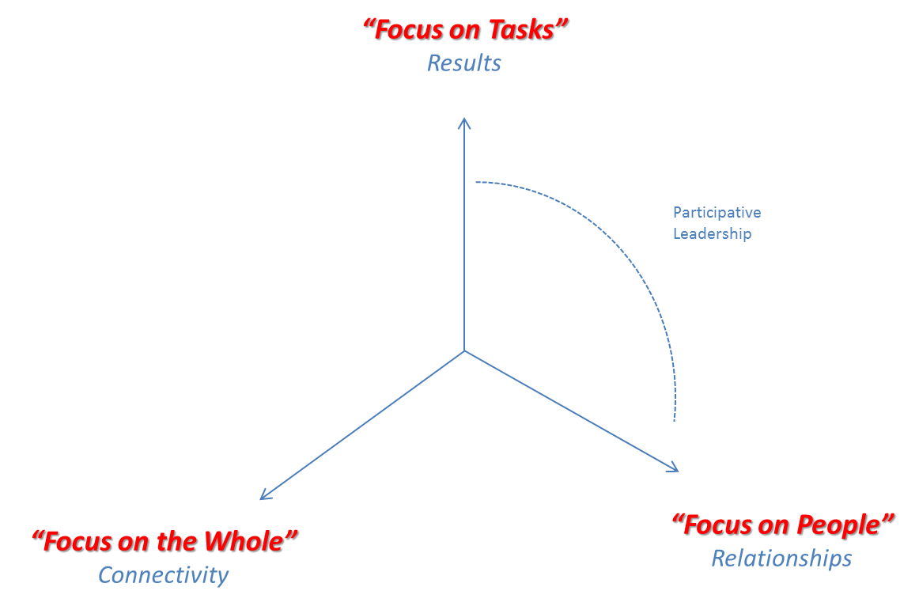

The Transmutation Process

We can call the path taken by a person towards integral leadership and this triple focus as a transmutation process. At the beginning of this process we turn to ourselves. We seek our self-knowledge, our intrapersonal relationship. It is similar to what is needed to become an Integral Human Being. But there are subtle differences since the goal is not only the Integral Human Being, but the integral leader. Thus, at this stage, the goal is to become an example of integrity, since that is how we can build confidence. Being an example is key to building trust, as it is a powerful signal of the behavior, values and principles to be developed.

Being an example is an important target and a huge responsibility, because it requires a tremendous effort to improve self-development, understand your fears, master your emotions, highlighting your virtues and learn how to live with your addictions, so that they do not interfere with the process and are minimized or integrated over time.
Nobody educates anybody, but nobody is educated alone. It is in human relations that we educate ourselves. The mutual education comes with the acts we practice (and observation), and has to be consistent with attitudes and not with empty words.

In this intrapersonal relationship phase (the leader with himself) is where he seeks to develop his skills. His technical knowledge as well as management skills will be the main pillars to improve performance and obtain results. This capability improvement in most cases is obtained in traditional business schools and specializations in the area of expertise. A doctor, for example, must know in depth the issues and dilemmas of medicine, its history, evolution, stage of technological development etc. The main philosophy in this phase is "everything that is worth doing is worth doing well”.

The second step is the development of relationships with others. The interpersonal relationship becomes the focus. Besides the atmosphere of respect and understanding, in order to develop in this phase of relations with others, the leader needs to dig into the great human needs. Understanding the human soul and spirit is the fundamental demand, as it is only through this understanding that the leader can contribute with the motivation of his team. Motivation comes from the intrinsic needs of each person and finds its source of energy in emotions. The leader who demonstrates a passion in what he does and effectively understands the needs of his team, being able to congregate human needs with business needs, will find a motivational environment.

It is important to understand, at this stage, that no one motivates anyone. Nevertheless, constructive behaviors can be developed by helping people to grow in their necessity scale.
The creation of an environment that promotes teamwork, that helps managing conflicts, and that enables collaboration with each other is the result of the leader’s for the people and for the development of human potential. Relationships flourish, increasing the maturity of the group that takes advantage of the environment to leverage results. Everyone wins with this!

Finally, the third step is the connectivity when the leader understands the dimension of the whole. Connectivity gets another connotation. When studied in the field of sapiential traditions, connectivity gained urgency with the need for understanding of what nature is and how man should relate to it. Is nature something that exists outside of men? Does it need to be conquered or dominated, and why? Is it eminently harmful, and therefore must be kept under control? Or does nature must be explored as it is our only source of resources?

Furthermore, connectivity has its purpose highlighted, as it is through it that the integral leader achieves vision at its fullest range. This thorough view is more than just seeing ways, it targets where you want to go and helps to create a desired future state, which is much more than just chasing scenarios. This powerful vision creates meaning for the group and organization stakeholders helping them to explore human creativity.

Figure 5: Humanistic Transdisciplinary Transmutation Process

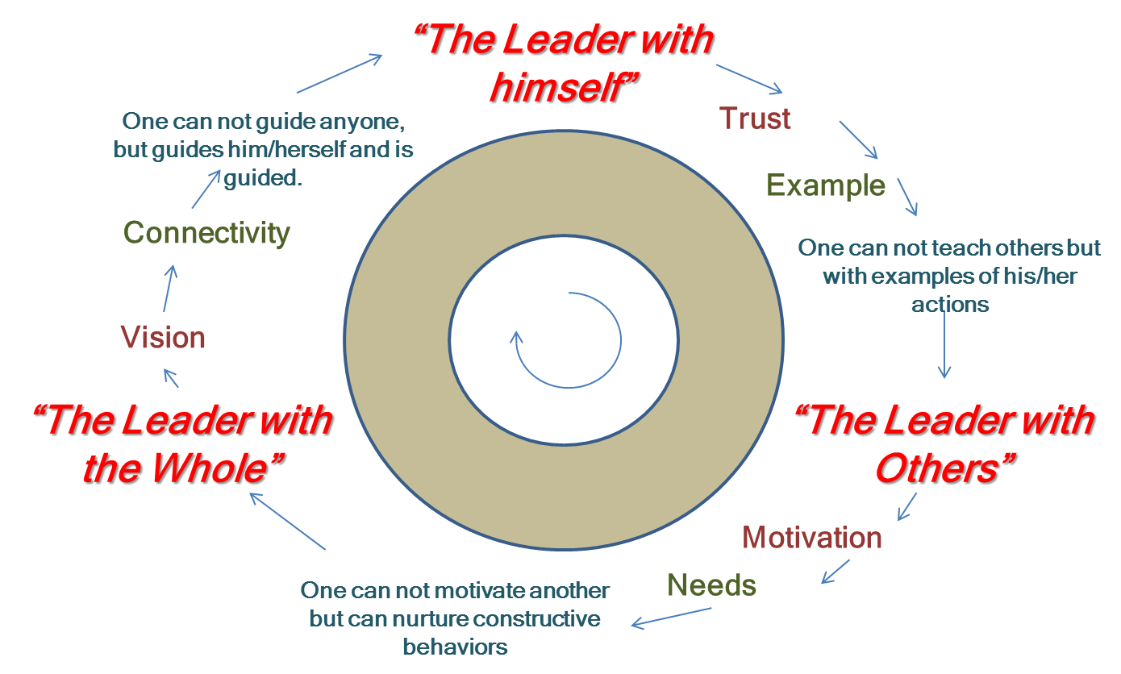

We can say that the great gurus, teachers and leaders of mankind in one way or another, have gone through a process similar to this in their path to creating better futures. Leonardo da Vinci was one of them. His vision and inexhaustible creative potential came from disciplined work, his intuitive need to look into the various disciplines as well as looking in between, through and beyond them. In his book "The Science of Leonardo da Vinci," Fritjof Capra shows exactly that facet of Leonardo.

Einstein also walked through a similar path. He could go as far as possible. His famous phrase "Genius is 1% inspiration and 99% perspiration" summarizes well the philosophy of humanistic disciplinary transmutation process. Another remarkable example is Gandhi, who self-transformed himself before building the confidence of his people and going to the unarmed fight to create a new future for his nation. Martin Luther King, Carl Jung, and many other notable men went through such a process.

From Infancy to Wisdom

We can summarize in figure 6 the stages that we should pass in the transmutation process in order to go towards integral leadership.

Figure 6: Stages of Integral Leadership

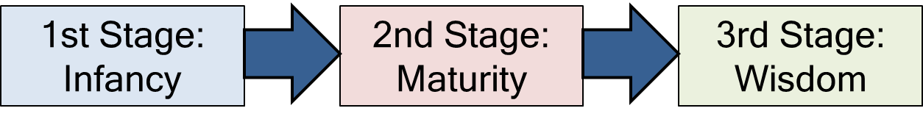

During infancy, the leader concentrates on tasks, techniques, and on fully understanding the concepts of his activities. He pursues excellence in execution and results. It is an initial step, which can take many years of dedication and study. But the man who is open and humane is still slumbering in his interior. It is a stage in which the focus on results practically dominates the time and attention of the leader. Unfortunately, empirical observation indicates that more than 80% of people in leadership or management positions, in the business environment, are at this stage.

At maturity, the leader turns to himself, to his interior, and also the people, the motivation, confidence, the real interest for others to develop and reach their potential. It is a higher stage of maturity that the leader performs without losing sight of the importance of the previous step. He is still a great performer of tasks, a high achiever of results. But at the same time understand his human potential, and potential of others. He understands that the relationship is the key to a more ethical result, longer lasting and more rewarding. Again, empirical observation points to only 10% to 20% of leaders being at this stage of maturity.

In wisdom, the leader integrates focus on tasks with focus on people; he is realized in them and still reaches the dimension of the whole, the access to his interior and the interior of all consciousness. At this stage the leader "guides and is guided." He achieves access to the whole, to higher consciousness and is able to have a broad, creative, exciting and meaningful vision. This is the stage of the masters, gurus, geniuses and great statesmen. And also some leaders, some men of great value who work quietly in their professions and in their companies. Unfortunately, this stage is still performed by just a few. But it is there, hoping that many can achieve it. This is the challenge of the new leadership for the twenty-first century.

The Differences to Traditional Leadership

The concepts introduced until now might give the impression that the differences between Integral Leadership and traditional leadership can be equated simply through adding a third “axis” of activities, or through adding a new set of knowledge. Though, these differences involve the objective, the method and of the learning mode; therefore, can be recognized as fundamental differences. Figures 7 and 8 demonstrate these differences.

Figure 7 - Traditional Leadership learning method

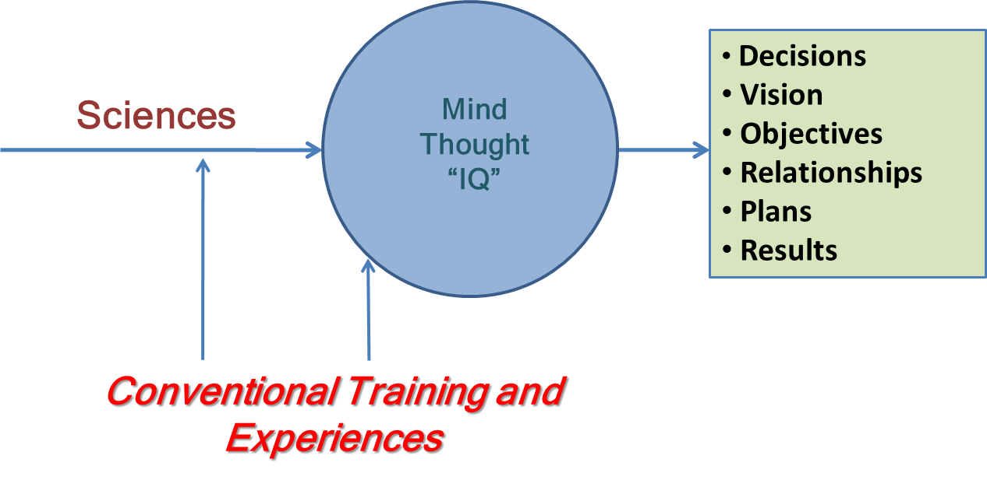

As we observe in figure 7, Sciences are the source of knowledge in traditional leadership studies; mainly Economics and Business Administration, and in some cases Psychology and other Social Sciences. We could add to this list: Mathematics, Statistics, Computer Sciences etc. In other words, there is still a fixation on pure objectivity, on considering the observer as an exempt actor, and on “technificism”; concepts brought to human knowledge by the Industrial Evolution and the Illuminist Movement. Our intent is to shed light to the current limitations of these concepts.

The way we process the knowledge from these scientific sources have been traditionally dominated by the “Thinking” function, by the use of Cognitive Intelligence (I.Q.). Most of the times, the training given to utilize this knowledge is limited to the standard schooling practices and to the conventional experiences lived in the classroom and the workplace.

Thus, using this arsenal of resources, this Traditional Leadership arrives to decisions, envision future paths, write action plans with goals and objectives, develop relationships and aim to certain results – which many times are brilliantly achieved!

But, to clarify even more which are the differences, we show on figure 8 what is the arsenal of resources that the new leadership counts on; the Integral Leadership.

Figure 8 - Integral Leadership learning method
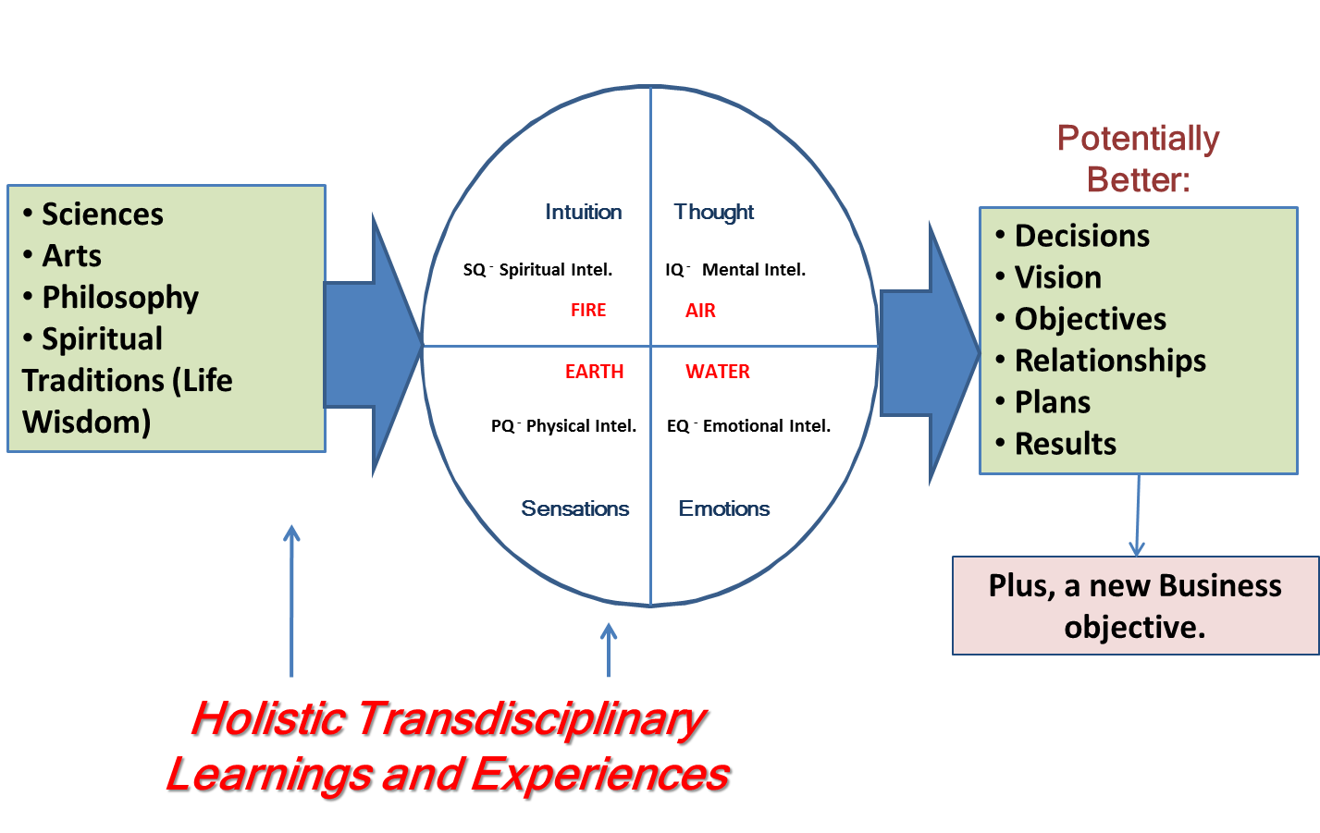

One can immediately see that this new leadership method is different. Firstly, it does not base itself solely on the sciences. Its knowledge sources are also based on the Arts, Philosophy, and on Spiritual Traditions (life wisdom). The biggest difference, though, in what Method is concerned, is to process the sources of knowledge through multiple intelligences. This can be a great leap in the formation of a richer mankind, a noble leadership, in the best sense of the term. One enabling himself to use his intelligence to its maximum potential is an ideal that justifies itself for its reach.

It is very easy to understand that this focus increases the probability leadership improving their decision making when making use of it; as leaders will be making use of ample sources of knowledge and as they will have an ample intelligence to work with.

We presume the knowledge sources to be reliable. This is a crucial point. As Science look to separate to its field of action knowledge that can be tested against certain methods – methods that can be repeated and applied in same conditions in different places – it limits itself.

Though, at the same time, this method has credibility in its affirmations (up to a certain point, as certain postulates change as new discoveries are made). Therefore, the great issue when one deals with philosophy or the arts, as well as the spiritual knowledge, is to look for support on the great avatars and masters recognized by mankind. It is all important to highlight that these other sources of knowledge do not exclude science; they are used in cases which science presents its limitations – for instance, in a case of Ethics during decision making, situation in which the knowledge source is supposed to be in the Philosophy realm.

On the other hand, there is no reason to question about a rupture with the exclusive realm of reason, the Mental Intelligence. It is not the case of leaving Reasoning behind (on the contrary, we rationalize more and more everyday); as, it is not the case either to use another Intelligence in some situations. As human beings are unique, wholesome, so is their intelligence. We are not talking about choice between Intelligences, but the use of all them combined. What Intuition discovers will pass through the analysis of Reason and by the senses of the Emotional Intelligence. Every Thought has an emotional charge; therefore, the ability to use multiple Intelligences is a unique potential that certainly makes a difference!

Learning in this new way of dealing with Leadership issues will also change; as it will make much more use of one’s transdisciplinary holistic experiences(which are provided in classrooms and / or field visits), as its model provides an opportunity to “savor” what is being learned (reason only learns a part of what can be learned in the traditional classroom setting, through verbal and written training; in contrast to the ability to learn as one experiences a phenomenon).

In what the final objective of the New Leadership is concerned, we understand we will potentially make better decisions; we will have the possibility of envisioning paths with an amplified vision. We will have the ability to put together broader action plans with narrower objectives and goals. We will develop more fulfilling relationships and we will achieve results that are the same of better than the ones we would get to under Traditional Leadership. There is an important difference though: we will be walking towards a new business goal as the result of the intrinsic characteristics of the Integral Leadership!

The “Central Triad”

To develop this Integral Leadership model we focus on three main pillars: Trust, Motivation, The Leader. This division is based on what is found in current literature on Leadership.
In most books about Leadership written in the last fifty years, one will find three major ways to tackle Leadership issues: there are authors that concentrate on understanding the profile of the Leader, what he or she does, what is his/hers personality, how to develop the required traits to become an effective leader etc. There are other authors that are concerned with how the follower reacts and behaves so the leader can exert his/her influence based on these findings. Finally; there are those who understand Leadership as a situational phenomenon; in other words, the best way to lead will depend on the situation in place.

As it could not be any different, in our model we use Integral Leadership as the best leader ship profile to be followed. The construction of this leader goes as follows: in what the Follower is concerned, we have found that, by far, it is important to understand what Motivation is – this phenomenon that is so idolized by rarely understood. In the Situational issue – in which each case requires a different response to it – what we found is the imperative need of the development of a Trust environment, independent of the context in case. For example, in an extreme emergency situation (e.g. a fire) the Leader will have to behave in an assertive way and demonstrate urgency; on the other hand, he/she will only be followed if the people around the Leader trust he/she knows what the path to be followed is.

Hence, this triad completes the Integral Leadership model, as illustrated by figure 9.

Figure 9 - The Central Triad of Integral Leadership

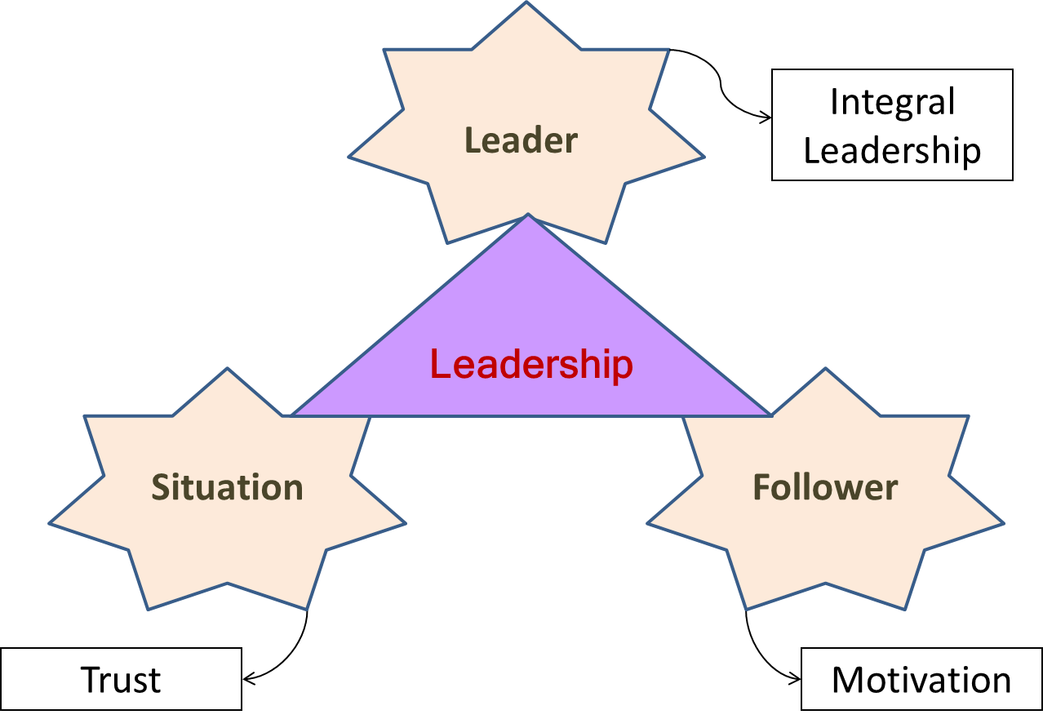

By shedding light on the need to develop the individual as a whole human being, one that focus, not only on Tasks and People, but also on being opened to the bottomless well of knowledge present in the different kinds of knowledge that human kind developed throughout history; the Integral Leadership model intends to provide the initial tools and to open a new path so that the Leader (as managers and as human beings) can take his or her organization from point A to point B effectively, and at the same time, fostering a collaborative work environment and leading an organization that respects and improves the society and the environment that it affects.

Practical Impact:

The change in leadership from the traditional science based approach to a model based on the whole, with foundations on a broader range of knowledge and experiences will drive renewal in management principles offering a broader purpose to organizations.

This innovative attitude creates an inspiring environment with greater trust and motivation which produces extraordinary results and allows reaching meaningful goals. Focus on economic feasibility will be accompanied by conscious behaviors towards social responsibility and ecological sustainability.

By challenging the leadership mentality essentially based on science, Integral Leadership provides means to overcome management dilemmas by developing leaders who can profoundly impact human lives and organizations providing a prosper outlook to capitalism.

Challenges:

The main challenges in applying this approach will probably reside on resistance to confront old paradigms; especially in organizations where shareholders have a tendency to make decisions based on the short term financial goals. Difficulty in cultural changes requires continual development and constant promotion of medium and long term goals.

The most effective approach requires commitment from top management, including shareholders, understanding the necessary transformation to confront paradigms of new capitalism.

First Steps:

Considering the importance of top management as key drivers in this process, first steps should include their participation in the learning process. They should go through the Integral Leadership development model themselves so that they can lead this paradigmatic revolution within their organizations.

End Notes
Credits:

Wanderlei Passarella, who has been coordinating and teaching the course of Integral Leadership.
Unipaz, educational institution that has been offering the Integral Leadership program.
Rafael A. Raphael and Frederico Almeida, representing the Alumni of the Integral Leadership course at Unipaz, as well as all other Alumni participants who have supported this initiative.

Tags:

Leadership, Integral Leadership, Transdisciplinarity, Holistic education, conscious management, Capitalism challenge

Materials:

http://www.unipazrj.org.br/lideranca.htm

