Creativity and high performance team collaboration

Andrew Gaines

Groups often perform far below what they are capable of because their members have not internalised high-level skills of collaboration. They do not have mental models of probing for understanding, building on each other's ideas, or designing for an outcome. People's ideas get blocked, discounted, misunderstood or simply neglected. As a result the group is uninspired, and produces mediocre outcomes. We see ‘bumper cars of the mind’ instead of high-performance collaboration.

In this article I describe a way of training that develops creativity and communication skills in a way that sticks. The approach is unusual.
Let’s imagine creating a culture of creativity within organisations, where people not only understand creativity, but embody it routinely and pleasurable in their ways of doing things together.

My approach is based on the recognition that all skills are patterns of coordination in the central nervous system. This is well known; you will find it in any standard neurophysiology textbook. The new bit is that with the right method it is possible to develop skills in one modality − say improvisational acting − that will be applied in quite different circumstances − say team communication. I call these functional analogues.

We can train so that skills become internalised, and hence available to be used spontaneously as appropriate. We do this by creating patterns of coordination in the motor system of the brain − the part that controls movement − that have the same operational structure as the skills we are interested in. These are functional analogues.

Thinking in terms of functional analogues opens up interesting possibilities for using creative modes of training to cultivate advanced communication skills. This is quite a different way of looking at things. Indeed, it is a paradigm shift.

In the first part of this article I give the theory of functional analogues. In the second part I show how to apply functional analogues to develop creativity and communication skills.

This is a long article with many anecdotes. My purpose is to give you both an overview and a feel for functional creativity. I would like to think that you will enjoy the process of reading it.

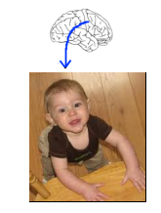
The theory of functional analogues

How skills develop in the nervous system

You have probably seen a toddler pull himself up by the side of a chair, teeter and then fall, only to pull himself up and try again. Neurologically he is working out how to coordinate the sensations of his feet with his leg muscles, the balancing mechanism of his inner ear, and the parts of his brain that coordinate movement.

Similarly, walking, playing sports and making music are all patterns of skilled coordination in the central nervous system. This description generalises. All skilled behaviours are patterns of coordination in the central nervous system. This applies in areas as diverse as teaching, team communication and running large businesses. True, there are intuitive elements as well, but even intuition becomes relevant when embedded in skilled behaviour.

Physical movement as the foundation of all skills

All skills are originally based on physical movement − meaning that all skills involve patterns of coordination in the motor system of the brain.

Neurosurgeon Wilder Penfield discovered a map of the body in the brain called the motor cortex. The motor cortex organises patterns of intentional movement. On the motor cortex the number of neurons devoted to each part of the body is not a function of the size of the part, but of the complexity of the movements we make with it. Thus the hand is assigned many more brain cells than the foot.

Here is the map Penfield made:
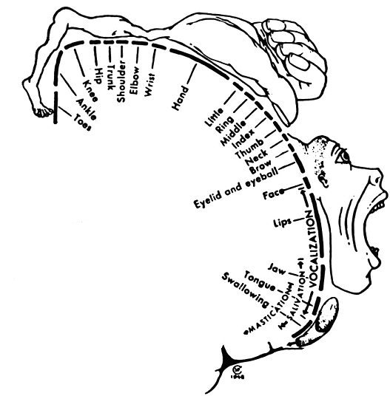

The neuro-anatomy is straightforward. The brain sends coordinated impulses to the muscles. They move the bones, and thus we carry out our intent in the world.
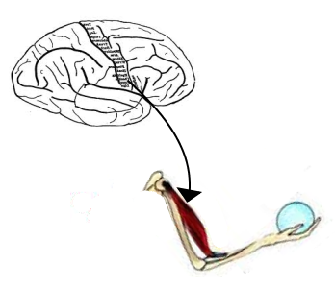

The importance of the motor system in vision

Just to emphasise the fundamental role of the motor system, I will show how physical movement is a crucial component of visual perception as well as of active skills.

In the late 1800s French mathematician Henri Poincaré asserted that our perception of three-dimensional space is not purely visual, but requires physical movement for the images on our retina (essentially a flat screen) to be interpreted as three-dimensional images.

An example from my own experience illustrates this idea. Mauna Loa Crater in Hawaii is like a barren moonscape covered with grey dust. It has few distinguishing features. I told a friend that I wanted to walk to an outcrop I thought was about 200 meters away. She informed me that it was actually 20 miles away. I would have discovered this, of course, had I started hiking. We calibrate our visual system through movement.

There have been instances of people who have been blind from birth who had cataracts removed when they were adults. They reported that at first they could not make sense of their visual perceptions. They could not recognise doorways as doorways until they gained some experience in moving with their eyes open.

The motor system is also the basis of mathematical abstractions.

- The French developmental psychologist Jean Piaget studied cognitive development in children. He worked out that childhood experience in moving objects provided the neurological foundation for all of abstract mathematics.

For example, numbers are the basis of arithmetic. Before we develop the abstraction of 'numbers’ we do things like figuring out which pile of candies has more than the other by matching pieces of candy from each pile. We put one from the first pile next to one from the second pile, and then match another pair, and another… until one pile runs out. These kinds of motor movements become correlated with counting − 1, 2, 3… You may recall counting on your fingers because at first the correlation is not very stable. But in time we can do mathematical ‘operations’ such as addition, modification and division purely symbolically. This opens the door to advanced mathematics.

Piaget worked out that there are three fundamental forms of mathematics − numbers, sets, and topological relationships − all of which were originally understood through physical movement. He was chuffed when he learned that the Bourbaki, a mathematics research group, had identified the same three fundamental forms as the basis of all advanced mathematics.

- Here is another example, again from the world of mathematics. Graduate students in mathematics often find it difficult to visualise a four dimensional cube. At two different universities, independent of each other, the mathematics faculty created a computer that combined a visual screen with handles that could be used to manipulate the visual representation of the four dimensional cube. Students could turn handles and rotate the object. This was a breakthrough; students rapidly learned how to visualise the cube. Engaging the motor system made the difference.

The motor system is deeply engaged in everything we do. When a basketball player practices a jump shot over and over, he is training his body, of course. However, more importantly he is treating his brain − the part that coordinates movement.

How I discovered functional analogues

My theme is that all skills are patterns of coordination in the central nervous system, and engaging the motor system is fundamental to developing skills. I made a discovery that leads to a surprising application of this principle.

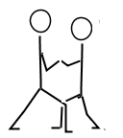
I developed a method of teaching people how to do a Tai Chi push. People learn how to use their legs effectively, and how to accurately sense the person they are pushing. At the same time, they discover how to use their whole body in an integrated way. I call it Connecting From Centre.

I developed Connecting From Centre because I wanted to teach people who work with the body to be more sensitive in their touch. However, people reported unexpected applications of the principles inherent in Connecting From Centre. Here are some of the stories. I am telling the stories, not to make a pitch for the virtues of learning Connecting From Centre, but to illustrate how skills learned through the motor system sometimes get applied in surprising ways.

- The mother of a boy with cerebral palsy said, "Lifting my son is so much easier because I use my whole body now.”

- A young woman wanted to get her furniture from her former boyfriend. He kept trying to throw her out, but she kept yielding, and he couldn't. Finally she looked him in the eye and said, "Jim, would you stop trying to hurt me long enough to let me take my furniture?" He did.

- A man aggressively attempted to push a Tai Chi student out of a bathroom. Without thinking about it the student applied the principles of Connecting From Centre, and the man's own force sent the man backwards almost into the glass shower curtain.

- A psychologist who typically played the role of peacemaker in staff meetings reported that she now speaks out and asserts her own views.

- A hard-driving businesswoman arrived in Chicago tired and frazzled for the major budget meeting of the year. She was about to enter the room and fight for what she wanted when she remembered the Relax-Connect sequence from Connecting From Centre. She settled herself down and entered the room open to see where they were at − and they gave her everything she wanted. Why not? She was competent.

- This is perhaps my favourite story. I taught Connecting From Centre to a psychotherapy client who was an engineer. For some reason I thought it would help his sexual relationship with his wife. But I did not tell him that; I just asked if he would be willing to have a go. Of course he said yes.

The next week he told me that he went home after our session and made the tenderest love to his wife that he had in 15 years.

So we have a technique for producing a Tai Chi push that produces a template of action in the motor system of the brain. The template is generic, meaning that many different applications can be generated from it. None of the applications mentioned above were planned in advance. They arose spontaneously.

When I first taught Connecting From Centre I had no concept of neurological ‘templates of action', although I did know that I was improving brain functioning. But when I worked out the concept I began to apply it consciously. I began to intentionally teach skills through the motor system that were to be used in another area of the person's life. Such skills have a common operational structure despite their different physical expressions; which is why they are functional analogues.

Developing skills through play

Here is an example from my Feldenkrais practice

I was invited to a neurologist's office to give a Feldenkrais lesson to an 11-year-old girl with cerebral palsy. She wore a hoop around her neck – not as a brace, but as a reminder when her head got too far off centre. She had been learning the Shakespeare sonnet that begins, "When in disgrace with fortune and men's eyes...” The neurologist and the girl's mother wanted me to help her with her speech. Feldenkrais never trained us to work with speech. But he did teach us how to think functionally about problems that we have never seen before.

I began by asking her to recite the first line of the sonnet. She did, with the constricted throat that many people with cerebral palsy have. When I asked myself what is she doing that makes the difficulty it seemed to me that she was choking herself.

As a first step in bringing the constriction under voluntary control, I asked her to recite the line again, but this time to do it as though somebody was choking her. I wanted her to intentionally constrict her throat.

She recited the line, but with no change in the way she spoke it. I was after results (and I have a playful spirit), so I reached over and pretended to choke her while she recited the line again. This worked. She hammed it up, and produced a really strangulated rendition. I imagine the neurologist in his blue double-breasted suit and vest and the proper middle-class mother both thought this was a weird procedure. But I was happy with it, because now she had some voluntary control of her throat muscles − albeit in the wrong direction.

Next I wondered what is the opposite of choking oneself? What do you think it is? I thought it was a sigh, so I asked, "Can you go 'ah'?" She did, letting her air out as softly and effortlessly as anybody else would.

Going 'hah,' which involves slightly more force, was also easy. So was 'heh.' I was creeping up on the first word of the sonnet. So far so good, but when I asked her to modify 'heh' into 'weh' her jaw went off to one side. So I invented a game to help her discover how to organise her jaw more effectively. I call it The Blowing Game.

She was to blow strong puffs of air directly at me. If her jaw was not well organised, then the puff of air would miss me. But if she organised her jaw well the puff would hit me. By accident she sometimes organised her jaw well. Every time she blew directly at my face I gave a dramatic response, widening my eyes and throwing up my hands as though I had been hit. She loved getting this response, and soon she was hitting me every time.

Now she could go 'weh' without her jaw going off to one side, and it was a short step to go to 'when.' But the 'n' was very lackluster. I recalled an exercise I learned from a voice teacher that activates the head resonators. You go mm-hm nodding 'yes' or um-um nodding ‘no’. Either way you can get a resonant mm sound. She really enjoyed going um-um and nodding 'no.'

Our time was up. I asked her to say the first word of the sonnet. She said, "When" - and it rang through the room!

For her blowing at me was a fun improvisation game. But the practical point was that without realising it she was working out how to coordinate her jaw.

People in the world of improvisation acting know that improvisation games teach collaborative skills. This is because if players don't spontaneously collaborate with each other the scene falls apart. Improvisation maxims such as 'don't block; go with' become internalised.

We can use improvisation games to teach specific advanced communication skills through play. By playing the games you gain the skills.

A special way of seeing

There is a special way of seeing that enables us to design functional analogues. Perhaps you've played the game, "What do you see in the clouds?" We look, and we see castles in the air, or whales or whatever. Seeing such similarities is a natural part of perception. It is easy.

However, these images are static. We are not so used to seeing similarities in movement. However, there is an improvisation game that cultivates this ability.

Object Transformations

Start a physical movement that involves an object − for example, bouncing a basketball. Transform the movement into something similar that involves a different object.

Thus the up and down hand movement of bouncing a basketball is similar to pumping a pump handle. So now you're pumping a pump, and that movement transforms into cocking an old-fashioned rifle. Squeezing the trigger of the rifle converts to a come-hither beckon, and that movement transforms to playing with a yo-yo…

Object Transformation prepares us for Scene Transformations.

Scene Transformations

Two people started a scene together. They know who they are in terms of their roles. They also know where they are and what they're doing. When one player senses that what she is doing could be part of a completely different scene, she switches without notice. Her partner is to pick up on the switch, assume an appropriate role in the new scene, and co-evolve it with her.

I did Scene Transformations as a performance for a class of eighth-graders I was teaching. I recognise that one of the girls was a natural actress. So I took her aside and briefly introduced the game to her. Then we went in front of the class and did a series of transformations.

She was a fortune teller and I was a client.
I became an old man hobbling, and she became a nurse helping me.
The old man's up-and-down gate transformed into riding on a carousel…

Here you can see that I am applying the very technique I am talking about. I identified a skill: the ability to see similarities of movement. And I came up with two games that cultivate this skill. Functional analogues.

Applying functional analogues

Here is example of consciously applying functional analogues.

Joan had a fifteen-year-old son. He was much bigger and stronger than she was, and he was very angry with her. She said he had good cause to be angry with her. In any case, she felt threatened, and wanted to learn how to handle herself so that she wouldn’t provoke him.

I wanted to teach her yielding – how to avoid an incoming force while maintaining her centre. This is not necessarily easy, since we have to stay present in the face of threat, while getting out of the way of the threat. Our instinct is to either resist or run.

In Aikido you learn how to yield when responding to a punch. You learn how to move off the line of the punch, turn and align yourself in the direction the punch is going, and accelerate the attacker’s movement in the direction he is already going. Because you have aligned yourself with the movement of the attacker, rather than trying to resist or divert it, there is no sense of conflict.

It seemed to me that practising with a physical attack would be too threatening for Joan. And besides, I wasn't trying to teach physical self-defence. I just wanted to develop her capacity to stay centred in the face of a potential conflict in a way that would not provoke conflict.

So I approached it playfully. I happened to have a ball about the size of a volleyball in the studio. I instructed Joan to step out of the way when I threw the ball at her, and to bat the ball past her in the direction it was already going. This movement has the same operational structure as the Aikido defence against a punch.

Joan reported that as a result she was able to stay calm and present at times when her son was right on the edge. She felt that this may have saved her from serious injury.

Working with the motor system can be very deep.

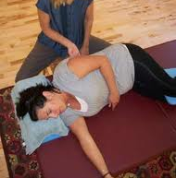
Mary came for her first Feldenkrais lesson when she was two months pregnant. I had her lie on my Feldenkrais table, and I did a gentle exploratory movement to see how free her shoulders and hips were.

I have discovered through some years of experience that some people hold their backs rigidly because of ignorance. They don't yet know how to sense their shoulders and spine, and move them freely. For other people, their rigidity is a form of resistance. They do not want to be pushed around. This was Mary's pattern.

I thought that this pattern did not bode well for her future relationship with her yet to be born child. All newborns make huge demands, and if she resisted them things would be very difficult.

Why do people get their back up, so to speak, and have a resistant body pattern? I think it is to preserve their autonomy. The young child resists being pushed around. Yet, now that she is an adult, she needs to be able to yield. How to teach her how to yield and yet preserve her need for autonomy?

I started by making the pattern conscious. I asked her to stand up and notice how she responded physically when I gave a gentle push from behind. As I had predicted to myself, she responded by pushing back. I asked if she noticed her response. She had not. So I gently pushed again, inviting her awareness. This time she noticed that she was pushing back against me.

Now that she registered what she was doing, I could begin to explore an alternative. I wanted to get a new pattern into her nervous system − into her neurological repertoire. I did this by setting her a problem. As I gently pushed her from behind her challenge was to find a way to respond that made her sense of the pressure from my hand drop to zero.

There are a number of ways to try to solve this problem that do not work. Some people bend forward from their waist; I just maintain my pressure as they bend. Other people walk trudgingly forward; I follow them, maintaining the pressure. The solution is to choose to walk rapidly forward − and move so quickly that I can't keep up. This is the direct opposite of the resistance pattern.

Once Mary got that, the next step was to turn the movement into an Aikido takedown. Instead of going straight forward she was to use the impetus of my push to initiate a spin that took her slightly to my rear. If she then put her hands on my shoulders, a backwards diagonal pull would easily make me fall down.

This is a basic Aikido takedown. Its relevance to Mary was that it provided her with a model of how to yield and yet preserve her autonomy. She yielded, but ended up in charge.

When she lay on the table to continue the Feldenkrais lesson her back was now relaxed and available.

Now another dimension comes into the story. I left Australia, and returned when she was eight months pregnant. Her back had remained supple. At one point during the lesson I happened to be sitting at her head as she lay on her back. To my surprise, Mary spontaneously began to do peculiar movements that I had never seen before. I had no idea what they were about. I leaned down and whispered, "You are in an altered state. Go with it. I will be here when you're done."

After a few minutes the movements quieted down. She opened her eyes, smiled and said, "I just rehearsed giving birth.” The actual birth was only four hours.

The theme of this paper is applying functional analogues to cultivating creativity and communication skills − and thus enabling groups to internalise skills that will spontaneously make group collaboration go much easier. Let’s get into it.

Applying functional analogues to developing creativity and communication skills

We only do what we know how to do, except in rare breakthrough moments. And we need to have skills in place before we are required to use them. If individual members of a group do not have an internalised understanding of how to operate with high-level skills of collaboration, then the whole group will tend to revert to the lowest common denominator default performance.

Bill Isaacs (Dialogue and the Art of Thinking Together, 1999) has shown that if you put an adversarial group together for long enough they will tend to move from fighting to listening to enquiring and finally to collaborating. His approach to dialogue supports such a positive evolution. Matt Taylor, co-originator of DesignShops, observes a similar process when people go through DesignShops. Ultimately people get tired of bumping heads. They get real, and then they get productive.

Perhaps some storming-norming is inevitable. But it helps if people have developed skills of collaboration, rather than having to invent them by trial and error.

In this section I outline specific creative thinking skills and attitudes that enable groups to be more effective and inspired.

Generating multiple definitions of the problem

As you may have observed, often groups argue over the definition of the problem.

An alternative is to start with a general discussion of the problem, and then invite each group member to generate one or more definitions of the problem as they see it. The facilitator picks one of the definitions, and the group runs with that. This avoids arguments over which is the best definition. If the group is not satisfied with the outcome of this first run, they can do a second run.
By framing the problem as a How To the mind moves into a proactive mode and begins to cast about for answers. This casting about takes us out of the box.

It is useful to define problems in the form of How to…? A How To might be pragmatic, such as How to get garbage from a submarine to sink undetectably? Or it might be fanciful, such as How to get birds to knock heavy snow off power lines in Alaska? (An answer to this one: fly a helicopter along the power lines!). Framing a problem as How to… immediately produces a proactive orientation.

An interesting feature of having multiple definitions of the problem is that one of the definitions may be a really insightful way of illuminating the essence of the problem.

Going with

Improvisational actors talk about the value of going with. Experience shows that if we directly contradict a partner’s offer the improvisation quickly falls apart. If our fellow player asks, “How was the train trip?” and you reply that you came by car, you are already at loggerheads.

So instead of blocking or contradicting, you accept the reality as they have defined it − you came by train − and build on that. E.g. “The train rattled so much I'm going to the dentist to get my teeth adjusted.”

Chain Story is an improvisation game that cultivates the skill of 'going with' directly. You may have played a version of it when you were a kid. One person starts a story. When the Director says, “Stop!” the next person picks up the story, and so the story builds, going from person to person.

When naive groups first play Chain Story they often go off on tangents, contradict what just came before, or completely ignore what came before. This makes the story disjointed and aesthetically unsatisfying to the audience.

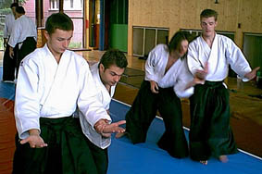
To help the group become more skilful at going with, I sometimes introduce the technique from Aikido that I mentioned in the anecdote about Joan and her 15-year-old son. The technique starts by getting off the line of an incoming grab, turning to face in the direction that the attacker is going, and accelerating the attacker in the same direction that they are already going. This completely obviates any sense of conflict.

When we return to Chain Story players visibly work much harder at going with what their partner has just presented in the improvisation. They absorbed the idea through the physical movement as well as through my coaching. This is another example of building neurological ‘templates of action’ through the motor system.

When we are working on a problem in a group, we can extend this idea of going with by following a line of possibility to its conclusion.

Following a line of possibility to its conclusion

Suppose a colleague offers a suggestion for a solution to a problem, or a way to structure a workshop. You have a different approach in mind. But neither of you actually understands the other' s approach, because you have not yet talked it through. If you immediately struggle for dominance, you have unproductive conflict.

The productive approach is to explore each other's idea. Draw your colleague out. Find out what they have in mind.

As you hear their idea, you may identify flaws. Rather than using the flaws as a reason to reject their approach, treat the flaws as problems to be overcome. Help them work around the flaws to make their idea stronger. Find a way to make it work.

I was once part of a small group planning an event. My colleague had one approach; I had another. So I took her out for coffee, and drew out her idea in detail. I had imagined that she would reciprocate by exploring my idea, and we could then compare the merits of the two approaches. That did not occur, and ultimately it didn't matter because the event did not get up. But why didn't she enquire about my approach? I think it did not occur to her enquire. She did not have a mental model of collegially exploring different action threads or prototypes.

In another circumstance I drew out another colleague’s thinking about an action thread that I had doubts about. As it turned out, when I simply asked him to explain his approach to me step by step the idea fell apart. Does this contradict what I said about making your colleague's idea stronger? No − I tried. However, not all ideas are worth developing.

So my suggestion is to follow a line of possibility to its conclusion… and then perhaps follow another

Inquiring for depth of meaning

Often people will use words that imply a whole world to explore. Someone might say, for example, "I've just made a new invention." Invention is such a word.

The listener has two choices: to skim right past this remark or dive deeper. If the listener's responds, “That's nice, my uncle made an invention once too,” the conversation stays on the surface. But if the listener says something like, "That's interesting, tell me more about it!” the conversation moves into the inventor’s world of thought.

In this interchange the term invention functions a bit like a metaphor. The term carries more meaning than is evident at first sight. I call the choice to explore that meaning unpacking the metaphor. Our conversations become more interesting and alive when we explore the depths of another person's thought.

In the absence of enquiry we often get misinterpretation, and as we know often this creates useless conflict. Therefore the ability to enquire into what other people mean is a crucial skill for high performance group functioning.

What does it mean to enquire? The Metaphor Process is a lovely process for opening the door to learning how to enquire well. We start by handing out natural objects − perhaps a pinecone, a starfish or a flower. People are instructed to describe their object in detail. Then they are asked, “If your object was a metaphor for a relationship, what kind of relationship would it be? Describe the relationship in terms of the properties of your object.”

The next step is to think of a real relationship, and make up a metaphor that captures the quality of that relationship. Each person is then interviewed about their relationship through the lens of the metaphor. The group only asks questions about the metaphor, never about the relationship directly.

This gives the people asking the questions the experience of enquiring with interest. The metaphor will stimulate them to think of imaginative questions, and often these questions generate surprising insights on the part of person being interviewed.

Going through the Metaphor Process gets the skill of enquiry into people’s neurological repertoire.

Thinking outside the box

Thinking outside the box is almost an acronym for creative thinking. Edward DeBono’s excellent techniques for stimulating lateral thinking are designed to get us out of our mental ruts.
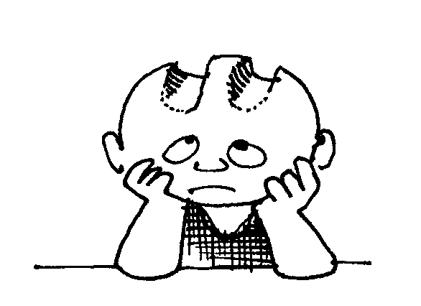
Rich Associations enable us to get out of the box spontaneously. I have observed that highly innovative people often use Rich Associations. This capacity is valuable in groups because it is a way of gaining access to the group's rich storehouse of knowledge and experience.

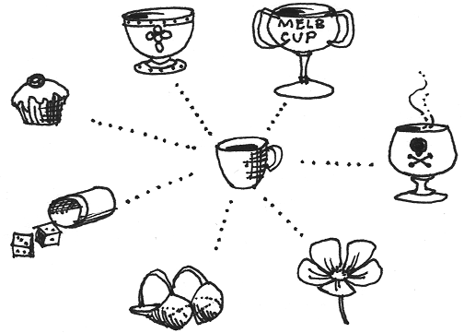
A Rich Association is a mental jump that takes us out of our familiar lines of thinking. A mundane set of associations might go from cup to saucer, teaspoon, coffee − all valid associations, but they stay close to home. A set of Rich Associations would go from cup to the Holy Grail, the cup Socrates drank hemlock from, the Melbourne cup… These kinds of associations have texture. They take the mind into interesting regions of thought, and thus add fuel to the creative fire.

Rich Associations are a natural part of creative problem solving. Inventors routinely scan their memory banks for offbeat ideas that may help with a problem they are working on. Or they scan the external world for toys or biological analogues that may do the same thing. Here is an example from the world of psychiatry.

Milton Erickson was the staff psychiatrist in a mental hospital in Fort Wayne, Indiana. He was committed to getting his patients out of the hospital and back to normal life.

One of the men on Erickson’s ward claimed to have no stomach, and he would not eat. Therefore he was tube fed. Erickson undertook to prove to the patient that he had a stomach. He had the staff tube feed the patient a combination of eggs and vinegar. What a stench! Obviously the smell was coming from the patient’s insides. He had a stomach.

“OK Doc – I’ve got a stomach,” the patient said, “but I won’t put anything in it.”

“Yes you will,” Erickson replied. “Tomorrow morning, just inside the glass doors at breakfast time, you will see a glass of water and a glass of milk on the table. You will be the first in line to drink them.”

Erickson had the staff feed him lots of salt at dinner, while turning off all the water on the ward overnight. In the morning, as predicted, the patient was first in line for milk at breakfast.

Having gotten the patient to drink, Erickson’s next goal was to get the man to eat. He sent the man out for a day with the wood cutting crew.

The weather was cold, and Erickson knew the man would be physiologically hungry when he came back for dinner that evening. Erickson asked the cook, a large woman who loved to eat, to skip her lunch, but to make twice as much as she could eat of her favourite dishes for dinner. She agreed.

When dinnertime came Erickson had the man sit across from her at her table. She ate with great gusto, relishing her food. After a time the man couldn’t stand it. “Cookie,” he asked plaintively, “could I have some of that food?”

“Sure, honey, help yourself!”

Where does such an idea come from? Erickson said he got it from his daughter. His daughter, watching their St. Bernard crunch a bone, exclaimed, “Daddy, he eats it with such relish it makes my mouth water!” Rich associations.

In terms of group communication, learning Rich Associations makes us more open to offbeat ideas. Instead of seeing different ideas as ‘dangerous’, we may see them as interesting. And, as the Milton Ericsson story shows, having ready access to Rich Associations can spontaneously enhance problem solving.

Visiting Expert

Visiting Expert is a game from Theatre Sports that forces us to think outside the box. It is like a television interview.

One person is the Interviewer. The Interviewer introduces the Expert as being expert in something outlandish or improbable. The Expert has no idea what's coming; his or her response must be made up on the spot. However outlandish the role may be, the Expert must say, "Yes, I do such and such…” and go on to make up an account of how they do it. The mind immediately becomes inventive!

This illustration gives the spirit of the game:
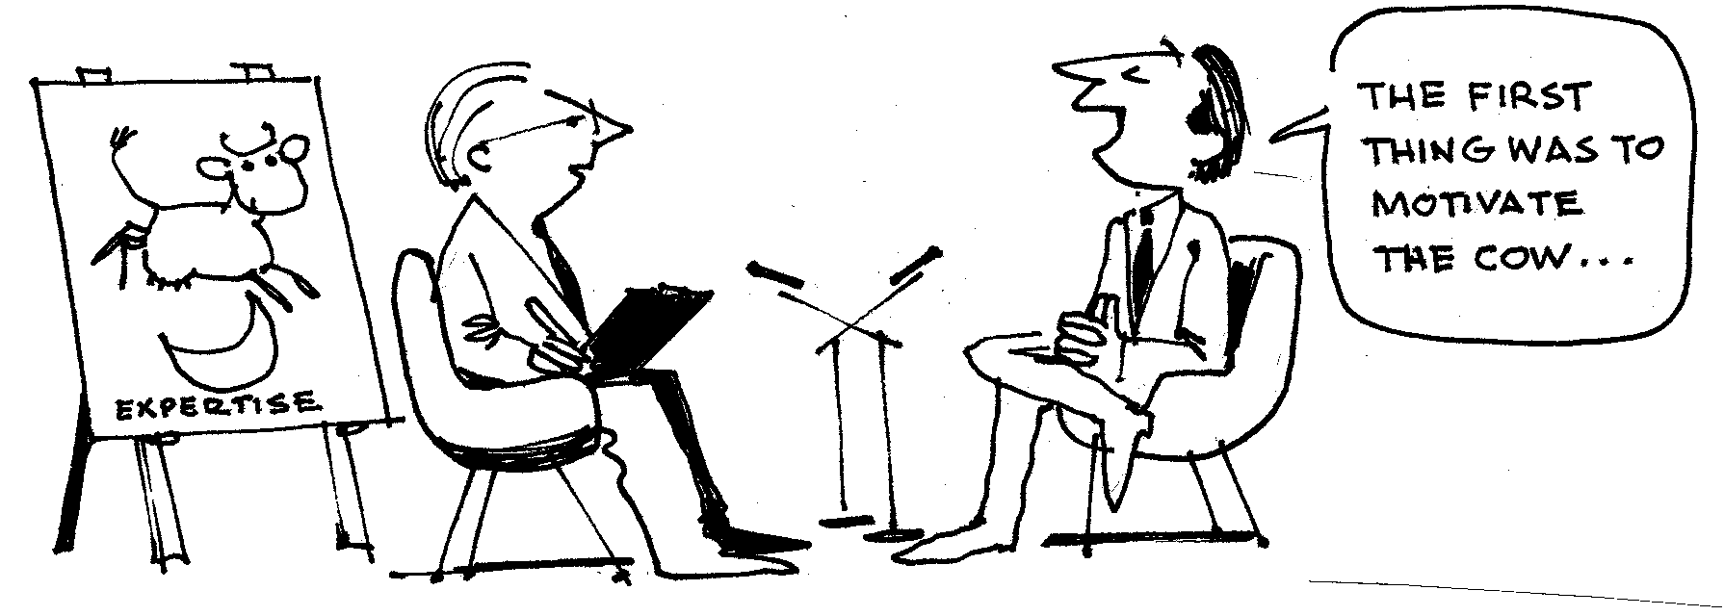

Visiting Expert can be adapted to be an interview with somebody from the future who has already solved your problem. How did they do it?

Visiting Expert gives people the experience of going into what I call creative space − a mood when inspired ideas seem to bubble up. At times individuals or groups will go into creative space. The thing to do then is to record like mad to catch the ideas.

The difference between making points and developing skills in the nervous system

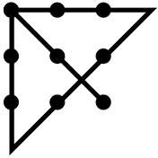
Rich Associations stimulate the brain to think outside the box. Learning to play with Rich Associations is functional, in the sense that it develops a neurological capacity that can be used spontaneously in ordinary life.

In contrast, do you know the Nine-Dot Problem? It is given in some training manuals. Its purpose is to stimulate creativity by thinking ‘outside the box’. Given a square of nine dots, your problem is to cover all nine dots with no more than four straight lines drawn without lifting your pencil from the paper.

To solve it we have to extend the lines outside the box, rather than staying within the apparent confines of the box. Once you get the idea, a smart-alec solution is to take a paintbrush and cover all nine dots with one stroke!

This may be interesting − but is it useful? Will solving the Nine-Dot Problem make us any better at actually thinking outside the box? I think not. As far as I can tell the Nine-Dot Problem just 'makes a point' rather than cultivating a skill. Skills, as I have said, are patterns of coordination in the central nervous system. They are developed through activity. By devising functional analogues we can develop modes of training that install skills that people will use in life.

Synectics

I regard Synectics as one of the truly great methods for problem solving in small groups. It was developed in the 1940s by William Gordon, and refined into a teachable technique by George Prince (The Practice of Creativity, 1970).

Gordon wanted to tease out mental techniques that inventors typically used, so that he could teach them to other people, and thus amplify a group’s creative horsepower. So he gave inventors and other creative people wire recorders and asked them to record their thought processes as they were working on problems.

He found that typically they started with an analytic phase to clarify the problem, and then went into a reverie when actually working on the problem. In this reverie they played with ideas and associations until they hit on a line of thinking that was relevant to their problem.

For example, Gordon recounts the story of an inventor who had a contract with the US Navy to improve their altimeter, the device that indicates how far the aircraft is off the ground. In the 1940’s the new generation of aircraft went up and down faster that the old altimeter could respond.

The inventor started by analysing the problem. He pulled the cover off the back of the sample altimeter the Navy gave him, looked at the gears inside, and promptly threw them out. "This can't be it," he said, "they are too cumbersome."

Next the inventor noted the "diaphragm," a flexible metal cover at one end of a sealed cylinder. "This is the heart of the device," he commented. "When the aircraft goes higher the outside air pressure becomes less, and the air inside this cylinder expands. That makes this diaphragm move outward. We have to have this, because it is a direct physical response to changes in altitude."

These thoughts completed his analytical phase. Next he noticed a flat coiled spring that transferred changes in the position of the diaphragm to the gears. "Hmm," he mused, "a spring. What is spring? Spring is a time of blue sky and green grass when apple blossoms bloom. Gentle breezes make the branches move...” This was the beginning of his reverie phase.

His reverie led the inventor to imagine a black cat dozing on a branch, being gently swayed by the breeze. This image seemed related to his problem. The inventor became excited. "Suppose I put a drop of ink on one of the coils of this spring. I bet that as the diaphragm moves the coil will move, and this ink spot will move with it in almost a straight line."

He tried it. It worked. "Great," he thought. "All I have to do is put a needle on the spring, and it will give me a direct readout of the changes in altitude." His problem was solved.

Gordon identified several mental strategies that inventors used in the reverie phase. He put them together into a process called an Excursion. The point of the Excursion is to intentionally make mental jumps that take you away from the original problem. In this regard an Excursion is analogous to making Rich Associations.

These mental jumps enable the group to tap into its rich storehouse of knowledge and experience that may be relevant to the problem.

There is a part of the mind that psychoanalyst Lawrence called the preconscious. It is a region of wit and imagination that seems to lie just below the conscious mind. When we give it a problem the preconscious goes to work gathering ideas that might contribute to a solution. It may even produce a solution. Many of us have had the experience of having the solution to a problem pop into our minds as we wake up.

The Excursion is a structured way of thinking outside the box. It activates the preconscious, and brings you to a set of ideas far removed from your starting point which are never the less related to your problem. These ideas provide a fresh approach to really challenging problems.

George Prince's The Practice Of Creativity is an excellent manual of Synectics procedures. It can be downloaded via www.archive.org.

Not every problem is challenging enough to warrant using Synectics. However, if you do a few Synectics excursions you will learn how to get movement with ideas. My book Creative Conversations (via lulu.com) shows how to learn the Synectics procedures by doing a Contemplative Excursion without needing an actual problem. The procedure is too long to include here.

Contemplative Excursions are valuable in their own right. They are another form of applying Rich Associations, and teachers can use them in the classroom to deepen students’ appreciation of concepts from art, history, literature, and science.

Recovering playfulness

Often one hears the comment that play is crucial to creativity. How do we do we make this operational? Well, all improvisational acting games evoke the spirit of play. So does playing with Rich Associations. There are other modes as well.

- When Bobby Kennedy was Attorney General of the US during the turbulent civil rights era his staff would often take a break to play touch football on the White House lawn.
- The Institute for Defence Analysis, a mathematical think tank in Princeton, New Jersey, has a custom of meeting in the library for speed chess and Go in the late afternoon.
- The head of an Australian medical technology company says that his group’s breakthrough ideas emerge from their Friday afternoon barbecues.
- A group of nuns who ran a large hospital complex in America had regular stimulus sessions on topics as varied as African drumming, finance and Tai Chi. These sessions both stimulated their thinking and brought them closer together.

Surrendering control

It is said that often managers maintain excess control because they are afraid to let go of control. Improvisational acting provides a safe arena for people to explore letting go of control, because there are no real-world consequences. Players discover that when they give up their attempts to make things go 'their way’, a quality of self-organisation arises in the group that often produces thrilling results.

This is not to say whether a manager should or should not relax control in a given instance, but we do well to surrender the fear that may stop high-performance group collaboration from emerging.

Thus far we have covered a few fundamental group collaboration skills which, if internalised, will greatly improve group functioning. Any investment in training in this area will produce immediate rewards − and they will be long-lasting because the skills become permanent additions to people's neurological repertoire.

The rest of this article looks at cultivating systems thinking, designing for an outcome, prototyping, and cultivating emotional resilience. Systems thinking is important, because all 'problems' occur in some larger context.

Natural systems thinking

In its simplest sense, systems thinking is just seeing how things work. It is a natural form of perception. Perhaps it is only made difficult because of years of formal education have taught us to think in terms of silos and isolated elements.

Natural systems as systems metaphors

Every natural process − beehives, how plants flower, blood circulation −is an integrated system that works. In DesignShops Matt Taylor sometimes hands out books and articles on say, beehives, and asks the group to work out how they work. Participants are then asked to consider how insights from how beehives work apply to their situation.

They are now looking at their situation through a systems lens, even though Matt has not necessarily used the phrase ‘systems thinking’. Thinking through how beehives work, or ocean currents, or the circulation of the heart, produces analogies for thinking about the business problem.

Mapping the system

Systems thinking involves integrating pieces of data into a coherent systems perception. Some people do this intuitively − they look at the social system or an ecosystem and just see how things fit together. In groups it can be useful to explicitly map the system.

For example (highly pertinent, since it deals with the foremost dilemma of our age) here is a way to make a one-page systems map of the major factors that drive environmental deterioration. I call it the Big Picture Map.

The Big Picture Map starts with a diagram that shows the connection between the production and consumption of material goods (STUFF, as Annie Leonard calls it in The Story of Stuff). The diagram works as an equation: the more stuff, the more the associated environmental damage.
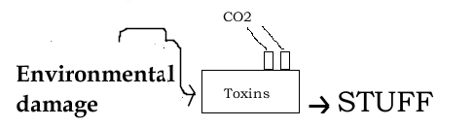

We add to the map the major factors that increase the production of stuff. They include advertising, global trade agreements, devotion to economic increase and population increase. There are psychological factors as well, including retail therapy as compensation for not feeling good inside, keeping up with the Jones in order to look as affluent as our peers, and the simple attraction of bigger, better and more. So our map that something like this:

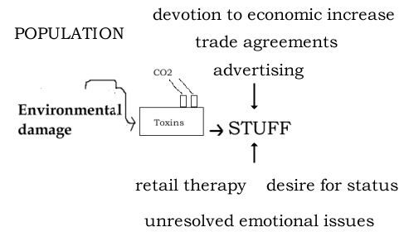

While more detail could be added to the map, this gives us a useful big picture overview. It enables us to see connections between the major elements − and also helps us make sure that there are no major elephants in the room that we are neglecting in our thinking. We can see all the major elements that must change if we are to have the prospect of a positive future for coming generations.

Here is a general template for working out more specific big picture process maps in a business context. Starting on the left, we take account of our inputs and also the larger social and environmental context. On the right we map the effects of what we produce on customers, staff, and also on the larger social and physical environment. These effects, of course, have a great deal to do with Corporate Social Responsibility.
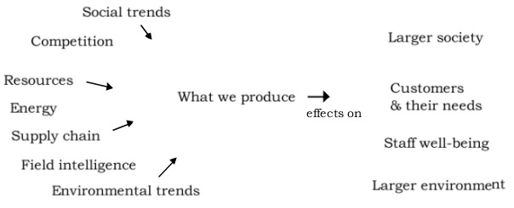

Functional systems thinking

Systems are dynamic. They operate in ways that produce outcomes we like, or adverse outcomes. The ingenious Israeli movement educator Moshe Feldenkrais pioneered a form of ‘functional’ systems thinking, and used it to help people with severe movement difficulties move better. One of his key questions is: How does the system operate to create the difficulty we see?

For example, if a client comes with pain in the left knee, we might ask: how does she organise her whole body so that she puts strain on her left knee, but not the right? Perhaps she has a tendency to walk with her left foot turned out. Or perhaps her left ankle rolls in. Or maybe she has a tendency to lean to one side in a way that strains the left knee.

The Feldenkrais approach does not focus on the symptom, but on how the symptom is produced. And our intention is to improve the functioning of the whole body so that the part that manifests the symptom is no longer stressed.

Suppose that the pain in the left knee has to do with a tendency to walk with her left foot turned out. The body works as a whole. So the Feldenkrais practitioner helps the client discover how to rotate her left leg so that her left foot tracks straight. But this realignment of the left leg effects the coordination of the shoulders, so the practitioner also helps the client discover how to achieve a smooth flow of movement from the foot through her torso and shoulders. Thus, she improves the functioning of the whole system.

Functional Integration, as Feldenkrais called his individual lessons, is very sophisticated. It requires both a sensitive touch and a good knowledge of biomechanics.

But the functional way of thinking that leads to systems improvements is familiar to us. For example, most of us have had the experience of getting a drawer unstuck. Is it stuck because the hairbrush is sticking up, or because the bottom of the drawer is warped underneath? We figure it out and clear the blockage.

Connecting From Centre, described below, is a model of intervening in a complex dynamic system to improve how it functions. It illustrates a more general way of thinking. And

Connecting From Centre

As I mentioned earlier, I worked out a way to use the Feldenkrais method to teach people how to do a well-coordinated Tai Chi push. In a few minutes even beginners can discover what might take them two years to discover through traditional training.

Everybody knows how to push, so we're not starting from scratch. But many people push in ways that are awkward. If we can discover what they do that makes pushing awkward, and help them discover a more integrated way to push, we can get an immediate improvement that is permanent. Here is how I do it.

I invite the student to take a comfortable stance and push me with one hand while I offer mild resistance. Their task is to make me take a step backwards without great effort. If they organise their body well, the task is easy (just as when groups function well their communication is easy).

There are a few typical things that people do that makes pushing me difficult. Some lock their legs and lean. Some muscle up and try to overpower me with force. Some try to trick me. None of these solve the problem.

There are two principles that make pushing easy. The first is that power comes from the legs. So instead of locking our legs we relax them and let them move flexibly. It takes only a few minutes to enable people to discover how to do this.

The second is to sense your partner accurately. Again, it takes only a few minutes for people to discover what this means.

At the end I have the student undertake to push me again. Now it is easy. Am I cheating? No. I have them push me in the old way − I am immovable. Then they relax and push me in the new way. It works. I have not changed my body organisation. The difference is in the way they organised themselves.

The creative question that emerges from this is: how does this system (individual, organisation, economic system…) organise itself in ways that create the difficulty we experience? I apply this question to helping people improve a Tai Chi push. I have also applied it to the big question of how does our society organise itself to make global warming and other environmental issues worse? The question is universal, and can be usefully applied whenever difficulties arise.

Systems diagrams with feedback loops

Donella Meadows and Peter Senge have popularised business applications of the approach to systems thinking pioneered by MIT's Jay Forrester. They describe the ways in which some systems have factors that tend to keep them in balance, and other systems, lacking these balancing factors, escalate to the point of being unsustainable.

Sometimes it is possible to recognise such dynamics intuitively. For example, our current economic system (consumerism, personal psychology, economic increase, & trade agreements) operates as one gigantic reinforcing loop that escalates both GDP and environmental damage.

Feldenkrais Awareness Through Movement as a way of learning systems thinking through the body

Modern public education is derived from methods developed in the 1700s in Europe that were intentionally designed to prevent systems thinking. The ruling elite wanted people to develop technical skills, but they did not want people to connect the dots and see how systemically oppressed they were. They did not want people to rebel.
Therefore academic specialties were taught in silos, with little reference to the social issues of the day. Such silos continue today as academic fiefdoms.

In parallel, much scientific research has been reductionist, focusing on isolated individual factors that can be quantified.

And for a variety of reasons many people are cut off from nature, cut off from their deeper feelings, and cut off from authentic connection with other people.

As a result, many people’s perceptions and ways of thinking tend to be fragmented.

In contrast, as mentioned above, the Israeli movement educator Moshe Feldenkrais understood that the body works as a whole. He devised a series of movement lessons, called Awareness Through Movement (ATM) that enable people to discover through their own experience that when we move well the body works as a coordinated system. Releasing something in the shoulder allows the legs to work better. We learn to sense the flow of movement through the whole body, rather than subjectively experiencing our body as composed of isolated mechanical pieces.

This shift from moving the body mechanically to moving the body as an integrated system is a profound paradigm shift. It is mediated through the motor system of the brain rather than being acquired conceptually through words or diagrams.

As a result of doing a series of ATM lessons we tend to no longer see the outer world as comprised of isolated fragments. We no longer naïvely accept single factor explanations (e.g., inflation is up because wages are up) that do not take account of the many factors that influence a specific outcome.

By doing Feldenkrais ATM lessons we learn systems thinking through the body. This provides a neurological foundation for doing systems thinking in general.

Skilled practitioners in medicine, psychotherapy, acupuncture and the Feldenkrais method of body education always start with a systems analysis. This orients them as to where to intervene. So they are not just analysing; they are aiming for a result.

Designing for an outcome

Architects and engineers also aim for results. They use a complete design-build process that not all of us are familiar with. It starts with understanding the site and the design brief. Then the initial conception, which might be expressed as a sketch, gets fleshed out in detail through the progressive stages of technical drawings, contracting and building, final finishing, and use.

Architects such as Christopher Alexander who want to produce superb buildings − buildings that make people feel alive − fine-tune the building on site as it is being built. In effect each stage of the building process is a prototype to be reviewed and improved.

Similarly, inventors make early prototypes of ideas, identify flaws, and improve them.

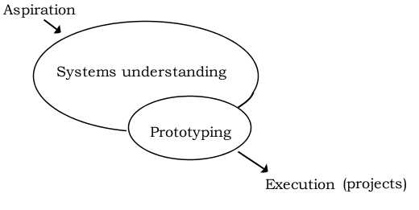
All of these approaches are results oriented, and all of them go through stages. A typical flow includes aspirations or goals, developing a systems understanding of the situation, prototyping and critiquing possible lines of solution, and real-world execution. Sometimes the systems understanding will come first. This whole flow can be called an action thread.

In my experience, very few people understand action threads. Instead, people tend to gravitate to one stage or another, and they may get stuck there. Some people resonate at the aspiration level, but do not have a path to making things work. Other people jump immediately to projects, but do not have a systemic understanding of what is actually needed. People may put up ideas, but they do not hold them as prototypes to be critiqued. Consequently they may feel attacked when flaws are pointed out.

So it is helpful to have a mental model of an entire action thread, and for people to know where they are in the process.

Earlier I suggested following a colleague’s proposed line of solution to its full conclusion. What we are doing is thinking through their action thread with them. Thinking through a colleague' s action thread enables us to understand what they have in mind.

In larger groups it can be useful for teams to develop action threads for different components of larger problem. These are prototypes.

Prototyping

A prototype is a working model or outline of how you might proceed to achieve your goal. It is not a vague aspiration. A prototype is thought through with enough detail to show how it could work. When other people see it they can understand your thinking, because you have spelled it out for them.

If members of a group are split about which way to go, it can be useful to divide into teams and work up each idea into a prototype. When the prototypes are presented back to the full group, each proposal will have the full attention of the group. There may be several rounds of critiquing and improving prototypes. One may be seen as clearly superior, or a synthesis may emerge.

Cultivating emotional resilience

Our unresolved emotions can interfere with individual and group functioning. There are various dynamics that show up as anger, avoidance, shutting down, competition, and overt conflict.

Sometimes these can be cleared by talking them out. They may be based on misunderstandings.

And sometimes they have to do with 'hot buttons’ in our own personal psychology. Therefore it is helpful if we have processes we can use for ourselves.

The first thing is to activate our Witness or Observer Self. The Witness is that part of us that can observe precisely what we do without judging. It is right next door to the Critic, which sees what we do and sometimes gives us holy hell for it! Simply learning this distinction frees some people from feeling so dominated by their internal critic.

Learning to activate our Witness develops our capacity to attend sufficiently to our internal states that we recognise that there is something emotional going on that we would do well to deal with.

This Object Concentration Exercise develops our Witness capacity as a skill. It is simple yet profound.

Object Concentration Exercise

Choose an attractive object to be your point of focus - eg a leaf, a flower, or an ornate old bell.

Observe your object for 4 minutes, following this internal instruction to yourself:

When my mind goes away I will notice that it has gone away and bring it back.

Processing: What details did you notice near the end that you didn't pick up at the beginning?

To see reality is a great creative act. By really paying attention we see things that otherwise we would not have noticed. This may break preconceptions.

In the context of cultivating emotional resilience our Witness enables us to notice our own reactions. So, then what do we do with them?

A useful starting point is to simply to notice them, without giving our adverse reactions any extra energy. In time our reactions will subside, because we are not feeding them.

Using a technique from the new field of energy psychology called Emotional Freedom Techniques (EFT) can be faster.

EFT

Emotional Freedom Techniques (EFT) is a major breakthrough in achieving emotional wellbeing. In 1980 it was discovered by accident that by just tapping on a few acupressure points with our fingers we can sometimes resolve emotional upsets with astonishing rapidity.
The EFT theory is simple. Normally our acupressure energy should flow smoothly. However, when the mind is in contact with a disturbing thought the energy gets out of balance. The disturbing thought could be a past traumatic experience, somebody angry in our face, or the prospect of giving a talk or going for a job interview. It could be something minor, such as irritation with someone's tone of voice. Or it could be something significant, like resistance to the prospect of exerting a new level of leadership.
We can rebalance the energy by tapping with our fingers on a few acupressure points. We are successful when our emotional reaction to the stimulus disappears, or reduces to virtually zero. Sometimes this shift occurs almost immediately. At other times it takes persistent digging to find and resolve the root issues.
Emotional competence is too important to be left to professionals. While sometimes skilled counselling is essential, there is a great deal we can do for ourselves. EFT should be in everyone's toolkit. Using EFT to deal with own emotional reactions is part of equipping ourselves to be effective members of high-performance teams.
You can download the free EFT manual from www.eftuniverse.com (via Learn EFT in the left column). The instructions are clear, and EFT is entirely safe. You cannot overstimulate yourself by tapping with your fingers on acupressure points.

Summary

An important question is how to get creative thinking skills into people's neurological repertoire, so they are available when needed? My approach includes using games that have specific creativity skills built into them. By playing the games you develop the skills. Although the games can be challenging, the learning is effortless and becomes embedded in our repertoire of skills.

The use of functional analogues in training is a creative breakthrough in its own right. On the surface they may look like 'fun and games' − something superficial. But underneath there is a profound insight into how the central nervous system works, plus a methodology for translating that insight into directly cultivating creative thinking skills.

As I mentioned, my book Creative Conversations is available through Lulu.com. It is a manual of games and exercises for developing advanced communication skills. It includes chapters on improvisation games, how to conduct a Synectics Contemplative Excursion, and how to integrate Rich Associations into creative conversations. There is also a chapter on cultivating pattern recognition.

I have talked about creativity, enhanced group communication, and cultivating emotional resilience. This vision of becoming happier and more creative is consistent with the great challenge of our generation: to evolve a society that takes account of environmental limits, and as much as possible brings out the best in people.

Andrew Gaines
Sydney, Australia
www.andrewgaines.net
www.applied-creativity.net
(02) 4782-2116

