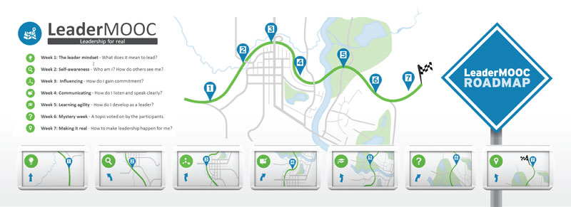

LeaderMOOC for People Who Don’t Have Time

LeaderMOOC took place in September and October 2013 and had over 4500 participants. LeaderMOOC is closed for enrolments now, but the content stays up until the end of 2013. This guide takes you through a short selection of the best of LeaderMOOC in 3 hours.
(In Word, click Ctrl+Click to go to the links.)
Home page: https://learn.canvas.net/courses/117
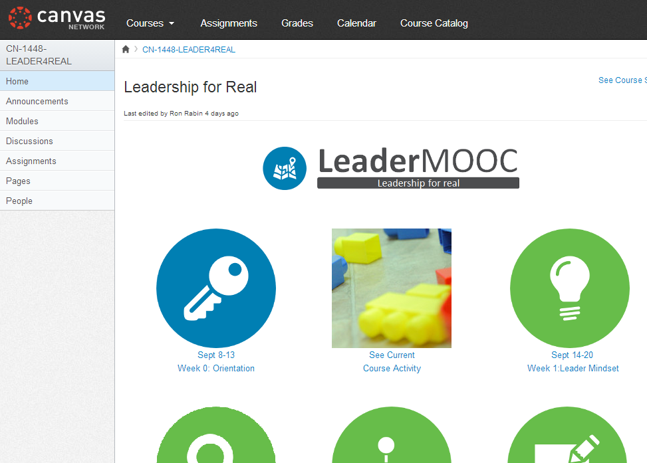
Week | Activity | Time
Orientation | Download and print the roadmap  The roadmap helps you to take your insights into goals. Every week we ask you to answer two questions. You can print the PDF and keep it next to you as you go through the MOOC. | 5 min
 | Watch the video “Why is leadership important?”  We asked various people in the leadership development field why leadership is so important. Here are their answers. | 5 min
Leader Mindset | Leadership Metaphor Discussion  What’s leadership to you? There are a million models and books on the topic. Browse through our most popular discussion forum (note: it has several pages) and look at the images people associate with leadership.  If you have 10 more minutes: answer the question yourself. | 5 min
 | Watch the Direction-Alignment-Commitment (DAC) video  According to CCL, leadership is about collectively generating direction, alignment and commitment. Watch Cindy McCauley explain how research on leadership evolved from studying individual leader traits to a collective process with DAC outcomes. | 8 min
Self-awareness | Watch why self-awareness is important for a leader  In the introduction video for the self-awareness week, Paula explains why self-awareness is important for leaders. | 4 min
 | Watch the Social Identity video  Watch Steadman walk through the streets of Addis talking about self-awareness and Social Identity Mapping.  If you have an hour more, you can download the Social Identity workbook and make your own map. | 8 min
 | Self-awareness: personality and choice  Watch Laura Santana explain how knowing what impact you have on other people is the key to choosing the most effective behaviour.  If you have 10 minutes more, participate in the personality and style discussion. | 6 min
Influencing | How to influence? Watch the video on influence styles  Chris Musselwhite describes the 5 influencing styles (2nd video on the page). Which one do you use a lot? Which one is most effective in a given situation?  If you have 5 more minutes, read Kate Herzog’s analysis of the influence styles JFK is using in his “we chose to go to the moon” speech in the JFK discussion forum. | 12 min
 | Who to influence? Watch the 3 characteristics of effective leader networks  Phil Willburn explains the three characteristics of effective leader networks. (2nd video on the page) How do they compare to your network?  If you have an hour more, download and print the Personal Network Diagnostic. Phil walks you through the tool in his videos. | 4 min
Communicating | Giving and receiving effective feedback (SBI technique)  Feedback is a key leadership tool, but there are ways to deliver feedback so it will have the intended results. Watch Phil Willburn and Nick Petrie explain and demonstrate the SBI technique.  If you have 10 more minutes, try out SBI in the discussion forum Practice the SBI technique. | 7 min
 | What we say and how we say it.  In this video Bill Gentry talks about the non-verbal communication. When the words and the body language don’t match, people will believe the body language. | 10 min
Learning Agility | What does it mean to be an “agile learner”?  Michael Campbell talks about the enablers and derailment factor of learning agility.  If you have 5 more minutes, fill in the How Learning Agile Are You self-test.  If you have 7 more minutes, fill in the Learning Motivation Scales research. | 4 min
 | Participate in the FeedForward exercise  FeedForward is a free technique developed by Marshall Goldsmith. Go into the forum and give feedforward suggestions to other people, or ask tips on your own most important development goal. | 15 min
 | How leaders develop across the globe  Meena Wilson talks about the latest iteration of CCL’s Lessons of Experience research. (1st video on the page) We know leaders develop through a mixture of formal courses, key relationships and challenging assignments. There are also global variations as Meena explains. | 8 min
Leading in Times of Change | This week’s topic was voted for by the participants.  Watch what change does to us.  Do you remember a recent change in your life and how you responded to it? Monica and Paula talk about what change does to us by taking a neuroscience perspective.  If you have 10 more minutes, share your own change experience in the activity Change Experience. | 15 min
 | How to lead people through transition  Most change initiatives don’t fail because of the change process, but because of the ‘people side’ of it: meeting people where they are and taking them where they need to go. Kerry Bunker talks about the paradoxes of leading change. (3rd video on the page)  If you have 30 more minutes, download the Paradox Wheel and fill it in for yourself. | 15 min
Making it Real | Setting goals through mental contrasting and IF…THEN statements  Leadership development is essentially about behaviour change. And behaviour change doesn’t just happen. Listen to Carol Connely and the two techniques she suggests: mental contrasting and IF…THEN statements. (2nd video on the page) | 15 min
 | Creating habits  Watch BJ Fogg (2nd video on the page) explain his Tiny Habits technique: trigger a new habit by attaching it to an existing one, and take small steps.  If you have 10 extra minutes, vote for little habits that make us more effective leaders. | 17 min
 | So why would anyone want to be led by you?  We hope this short selection of the LeaderMOOC content have giving you more insights, and an answer to the fundamental question: why would anyone want to be led by me?  If you have 3 more minutes: watch Kat’s answer to this question. | 2 min

www.leadermooc.net
www.ccl.org

