Introduction
A Systematic Approach to Building Innovation Capability:
The Titan Innovation Challenge Programme
Rishikesha T Krishnan, Professor of Corporate Strategy & Policy, IIM Bangalore
Pavan Soni, Fellow Student, Corporate Strategy & Policy, IIM Bangalore
Organizational capabilities are the bedrock of corporate strategy as they provide sources of sustainable competitive advantage. An organizational capability is the ability of a firm to deploy resources towards a desired result on a consistent and systematic basis. A capability can be said to have been created when there is a “regular and predictable pattern of activity made up of a sequence of coordinated actions by individuals.”
There are a wide variety of valuable organizational capabilities – responsiveness to market trends, acquisition integration, flexibility in manufacturing, and continuous improvement are some prominent examples. Some organizational capabilities get built owing to historical and path dependent factors – e.g. many Indian pharmaceutical companies built strong chemical process development capabilities because of the intellectual property laws and government regulations applicable to the Indian pharmaceutical sector. But the more interesting challenge is to deliberately build organizational capabilities.
The strategic management literature recognizes several ways in which an organizational capability can be developed. One key ingredient is possessing the necessary portfolio of skill-sets either through external hiring or internal development. But what distinguishes a capability is that it is embedded in the organization, and not dependent on just the individual genius of a few employees. Hence, capability building involves building team-based competencies through training and team development. Capability-building, like any organizational change process, usually involves some realignment of structures and systems, and change management to modify values and behaviours. Another allied requirement of capability-building is the creation of a knowledge management system that facilitates the creation, storage, and retrieval of relevant knowledge.
Capability-building is not necessarily an in-house activity. Alternate methods of capability building include the use the strategic alliances, and acquisition of other companies that possess the capability sought to be created. If the capability to be developed requires values and behaviours very different from those prevalent in the company, it may be done in an isolated organizational unit that is largely outside the purview of the company itself.
Capability-building is an ongoing process. It happens through a “learning-by-doing” process. Some of the steps involved include importing knowledge from outside, problem-solving, integrating, and experimenting.
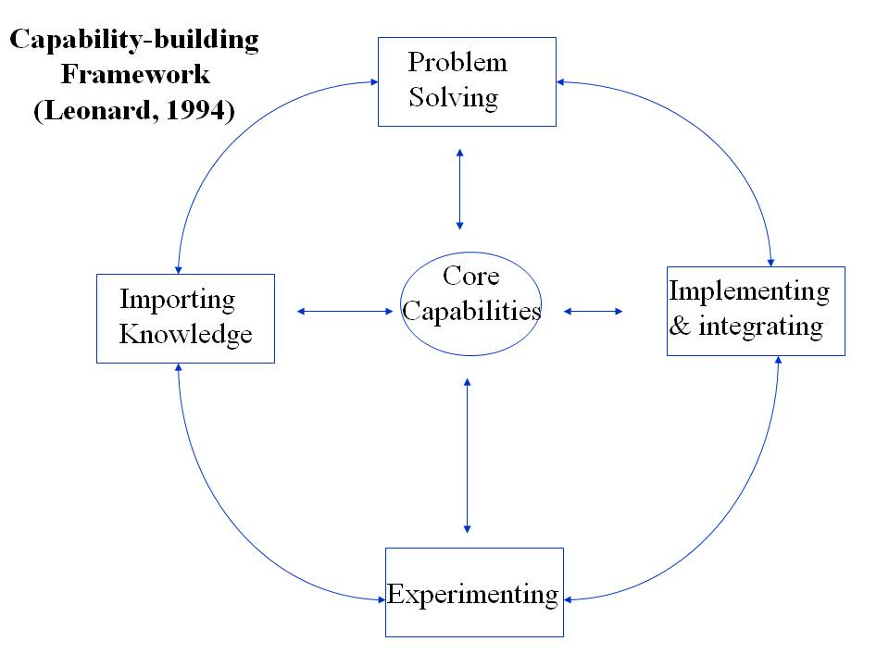
Innovation is one of the most powerful capabilities a company can have. Though innovation is most commonly associated with the development and launch of new products and services, innovation is much more than that. Innovation is the ability to apply new ideas to solve problems, address challenges or improve organizational performance with a resultant utility or benefit to customers, the organization, or both.
The Global Innovation 1000 Research Report published by Booz & Company suggests that it’s not the spending on R&D that help firms become innovative but the secret lies is the particular combination of talent, knowledge, team structures, tools, and processes — the capabilities — that successful companies put together to enable their innovation efforts. The report further shares the significant innovation capabilities as: Deep consumer and customer insight and analytics; Ongoing assessment of market potential; Engagement with customers to provide real-world capabilities; and Pilot- user selection/ controlled rollouts.
Innovation is increasingly regarded as one of the key competencies at the individual level as well. IBM recently identified ‘Capitalizing on Complexity’ as the key trait of a leader, based upon1,500 face-to-face interviews with CEOs of companies from across 60 countries and 33 industries. In order to capitalize complexity, the most critical competency identified for leaders is ‘Creativity’. This research substantiates the already rich literature existing on the virtue of innovation and creativity in organization’s continued success. Innovation is not just deemed important for the leadership, but also for front-line managers, and is regarded as a capability that needs to be systematically nurtured and ardently protected.
Creating an innovation capability involves the development of both individual skills and team-based competencies. In this paper, we outline the rationale behind, and the process used, in a recent initiative to build innovation capabilities in Titan Industries Ltd. (Titan). Titan is already known as a highly innovative company that has transformed the Indian watch industry, built a highly successful design-driven jewellery business, created new retail formats, created an iconic youth brand, and launched the world’s slimmest water resistant watch (The Edge). The top management and the Innovation Council of Titan desired to take their innovation capabilities to a even higher level. Given the high quality of Titan’s employee base, the positive corporate culture, and the strong belief that the company can do anything it sets its mind to, the objective was to build such capabilities internally rather than consider other options.
Titan invited the Indian Institute of Management Bangalore (IIMB) to be its partner in designing and rolling out such a capability development initiative. A second prominent partner was Erehwon Innovation Consulting, India’s leading consulting firm in the innovation domain.
This paper is structured as follow. We outline the broad Design Philosophy and Choices made, followed by details of the programme structure.
Design Philosophy & Choices
The design of this initiative was deliberately done in a spirit of co-creation between the core team at Titan (Mr. L.R. Natrajan & Ms. Meera Harish) and the programme director from IIMB (Prof. Rishikesha T. Krishnan). The Titan core team brought in the inputs from the Titan top management and Titan Innovation Council, while the IIMB programme director brought in his own and IIMB’s experience in designing leadership development programmes and innovation programmes for a wide variety of Indian and international corporate clients. Co-creation is commonly recognized as a powerful way of bringing in the best design elements to any new development initiative.
The key decisions that had to be taken upfront were the objective and broad structure of the initiative, its duration and location, and the choice of participants.
Objective & Broad Structure: There was a consensus that the objective of the initiative is ‘preparing participants to be catalysts of innovation within Titan, and laying the foundation for an innovation culture’ within the company.
In keeping with the capability development paradigm outlined in the Introduction section, the following were identified as essential elements of the programme:
- Motivation for Innovation
- Conceptual & Contextual Knowledge related to Innovation and Innovation Management
- Skills to be an effective innovator
- Values and behaviours required of innovators
- Time and space for problem-solving and experimentation in teams
Duration & Location: The duration of the initiative followed from the objective and broad structure. The “classroom” part of the programme had to be long enough to accommodate the key knowledge inputs required as well the guest speakers. A part of the creative problem-solving skills inputs and a broad understanding of the innovation challenges was thought to be ideally a part of the classroom sessions as well. Based on an inventory of the topics to be covered, and the time taken for each, it was determined that 5 days (one working week) would be the right duration for the classroom module. Since “learning by doing” was essential to internalize the skills, learn from each other, and develop creative confidence, it was felt necessary to have a week of laboratory work – i.e. working on the challenges – immediately following the classroom sessions. Though it was recognized that the challenges could not be completely addressed in a week, and that further experimentation and trials would be required, it was estimated that one week would be adequate to complete this initial “learning by doing” phase.
For maximum impact, it was determined that the programme should be done outside the office environment, preferably in an environment conducive to creativity and innovation. Thus the first week of classroom sessions were held at the IIMB campus and the second week of laboratory work at a nearby resort.
Choice of Participants: The value of conducting offsite programs for strategy formation is well realized by organizations, and there is a growing trend for companies taking two to three days off in a year with the leadership team deliberating on their following year’s strategy. Equally popular are the specific interventions conducted by the organizations’ Training & Development departments on both technical and inter-personal skills, among other identified gaps. But, interventions on innovation are quite unique. Neither are they at the level of strategy formation, nor under the ambit of Training and Development departments. These interventions call for an intense effort by a specific team whose charter is to influence innovation within the organization.
Given that this was the first such initiative and that this would be seen as an important trial of the effectiveness of such programmes, the choice of participants was considered critical. Senior middle management was identified as the ideal source of participants. Thus the participants were chosen to be typically functional heads within business units, sales heads of important territories, etc., all with a good track record and enjoying credibility within the company. The intention was to cut across functions and business units so as to create a critical mass of innovation catalysts and champions across the company. The participants came through a nomination process overseen by the MD of Titan, Mr. Bhaskar Bhat.
Details of Programme Structure
- Motivation for Innovation
An important intent of the programme was to instill a sense of belief and courage amongst the participants to take up innovation challenges. This was achieved by inviting successful innovation practitioners from leading firms to co-participate in the programme, organizing field trips to innovative companies, and encouraging the participants to socialize with the external innovation experts. Practising managers from Tata Motors and Nokia, and innovation experts from Tata Quality Management Services were co-participants in the programme. Identifying meaningful innovation challenges that were commonly accepted as important to the company’s future competitive success was also believed to enhance motivation for innovation. Involvement of the top management was expected to give cues about the importance of the programme. Titan top management attended many of the guest talks. Titan MD hosted a dinner for the participants during the programme.
- Conceptual & Contextual Knowledge related to Innovation and Innovation Management
Innovation means different things to different people. An incremental innovation for someone may seem to be disruptive for another and a near impossible feat to yet another team member. To get everyone to a common understanding on the subject of innovation and enable an appreciation of the underlying concepts, it was considered essential to have a common vocabulary of innovation as a starting point.
Being as much of a science as an art, innovation has its share of best practices which have been honed by leading organizations for years now. The knowledge sharing sessions intended to expose the participants to the best practices from the field, such that these could be easily adapted to Titan’s context. Case studies and presentations were identified as the appropriate pedagogy for such knowledge sharing.
Among the different types of innovation, business model innovation has come to the forefront in recent years, particularly to address under-served and unserved markets. It was therefore considered important to address this as a separate academic session.
Contextual knowledge such as emerging social and demographic trends and how they are being addressed in the creative arts related to Titan’s business (advertising, films, etc.) were another relevant type of knowledge for Titan managers. Guest speakers were identified to be the best source of such contextual knowledge.
- Skills to be an effective innovator
One of the key aspects of innovation management is to have a systematic approach to problem solving. With years of experiencing in coaching organizations on problem solving techniques and having worked with Titan in the recent past, Erehwon was best suited to help guide the team through the necessary creative problem-solving approaches. The classroom session of the first week was followed by hands-on creativity session through the second week.
Ethnographic methods were identified as another important skill to be developed to innovate effectively in a complex environment such as India. A leading practitioner/consultant of ethnographic methods was identified to be the ideal source of such a perspective.
Tacit Knowledge of innovation was provided by the presence of innovation managers from Tata Motors and Nokia, and consultants from Tata Quality Management Services.
- Values and behaviours required of innovators
Developing an appropriate organizational culture for innovation involves both understanding what are the elements of such a culture and how the organization stands vis-à-vis such elements. This was considered to be an important area for academic inputs.
The values and behaviours required for innovators were also expected to be communicated through the guest speakers and the participants from innovative companies (Tata Motors, Nokia).
- Time and space for problem-solving and experimentation in teams
Providing enough time and space for ideation and experimentation is an essential pre-requisite of innovation. The programme design therefore incorporated a significant amount of time for applying the tools and techniques taught.
In order to contextualize and concretize learning, it was important to have participants apply their insights on real business challenges. These challenges were drafted in such a way that they were ambitious enough to be taken up, yet solvable in the near future. The teams were given five challenges from across the organization. These challenges were identified by the Titan Top Management and the Titan Innovation Council. A list of the challenges in available in Appendix 1.
Innovation Challenge Programme Details
The first week of the programme hosted at the IIM Bangalore campus was focused towards learning in a classroom setup, while the second week involved “learning by doing” at an offsite location. The overview of what transpired through each of the two weeks follows:
- Week I @ IIM Bangalore Campus: The programme at the campus was residential and many participants chose to stay at the campus, experiencing the scenic beauty that it has to offer. Each of the five days had sessions from 9 am till the evening, punctuated with small breaks. While about 40% of this week was taught by the faculty members from IIM Bangalore, the remaining sessions were from experts from the industry and consulting companies.

Mr. Bhaskar Bhat did the context setting on day one followed by a series of interactive sessions on topics including: basics of innovation management, building an innovation culture, product innovation, business model innovation, co-creation and open innovation, ethnography, and on measuring innovation. There were also session on tools and techniques of problem solving conducted by Erehwon and some interesting perspectives on innovation shared by leaders from Nokia, Yahoo!, Lowe Lintas, and Future Brands. The innovation challenges were introduced towards the end of the week one, such that participants could start thinking about those before getting into the field exercises.

- Week II @ Offsite with Erehwon: Equipped with the motivation, innovation vocabulary, tools and techniques of innovation, the team then went hands-on to the second phase of the intervention. Dubbed as ‘Leveraging Innovation for an Orbit- Shift’, the session had a set of brief talks followed by extended hours of group exercises in an informal setup. The exercises intended at helping teams in their specific challenge areas and identifying possible blind-spots. Experts from Erehwon gave guidance on generating and synthesizing insights, and prototyping. Being an incumbent innovation consultant for Titan, Erehwon also played the key role of relating the learning and working from the workshops to Titan’s business.
Assessing Programme Effectiveness
This paper is being written about a month after the completion of the two-week Innovation Challenge Programme. Some of the metrics available at this point are:
Feedback on sessions: The feedback from participants on the sessions held in week1 indicates a high level of quality and appropriateness of content. Only a couple of sessions had feedback scores that suggest major changes are needed. The other sessions require just minor tweaking.
Participation in Programme: The Titan participants in the programme were seen to be fully engaged and involved in the programme. Motivation was not an issue and participants participated enthusiastically in all the programme sessions. Informal feedback from IIMB faculty indicated that this was one of the most engaged groups they had worked with.
Quality of work on challenges: The participants presented their work on the challenges to senior management of Titan at the conclusion of the two week programme. They also made a subsequent presentation to Mr. Bhaskar Bhat. The consensus was that the ideas and proposals generated indicated a high level of creativity and learning from the programme. However, many of them would need to be experimented on, and improved further before launching in a real business context.
Changes in Behaviour/Embedding Learning: One of the softer measures of the effectiveness of the programme is the change in behavior of participants. By the end of the programme, the new vocabulary had been internalized and was being used by several participants. Some Titan business leaders reported that participants were using the Innovation Challenge Programme vocabulary and approaches in their regular business meetings as well.
While all of these are promising signs of the effectiveness of the programme, there is a need to develop and use more specific metrics to measure programme effectiveness and efficiency. One of the best practices of measuring the effectiveness of innovation efforts is to assess it across Input, In-process and Output. Based upon work by BCGon measuring innovation returns, these are some of the possible metrics useful in this context (indicative):
- Input Measures: Financial resources committed; People committed (how many and how are they utilized).
- In-process Measures: Number of new ideas generated, number of suppliers and partners involved, number of innovation catalysts and champions available to the company, quality of innovation support available to others.
- Output Measures: Incremental business generation / cost savings / efficient improvement due to the innovation challenge programme.
Some areas to assess in the long term are: scaling the process without dependence on external consultants; percolating the learning to the lowest levels of the organizational hierarchy; creating measures of innovation that suit the company and industry Titan operates in; and how could Tata Group leverage Titan’s experience.
Key Success Factors
All available indicators suggest that the programme has been successful in ‘preparing participants to be catalysts of innovation within Titan, and laying the foundation for an innovation culture.’ In order to ensure that the learning from the programme could be used in designing future interventions, and for such events to be scalable across other Tata Group companies, it is important to identify the key factors that led to the successful outcomes of this initiative:
- Leadership Commitment in Action: The MD of Titan Industries, Mr. Bhaskar Bhat led the cause of innovation right from the front. Right from identifying the participants to vetting the challenges and being personally present to kick start the workshop, Mr. Bhat’s involvement was visible. He also scheduled reviews on progress of each of the challenge teams and took keen interest on the progress of various tracks. Such involvement not only instills confidence amongst the team members but also signals the utmost seriousness with which organization looks at these endeavors.

- Credible Innovation Champions: The innovations champions in the form of Mr. LR Natarajan and Ms. Meera Harish built the essential thrust to keep the programme going. Such champions need to have credibility coming in from their long association with the organization and impactful work, apart from a certain seniority to mobilize action on behalf of the leaders. With Mr. Natrajan’s credibility in manufacturing and innovation, and Ms. Meera’s enthusiasm for innovation coupled with coordination abilities at the corporate office, the two formed a very effective combination to spur action. Even with the senior leadership’s commitment, such interventions can’t go a long distance unless there are credible people championing the cause.
- Co-creation: Co-creation of the programme by Titan and IIMB enabled optimization of design, identifying the most appropriate guest speakers, and customizing the programme to the requirements of the company. It enabled a wider variety of ideas to be considered during the programme design phase.
- Well-Articulated Challenges:Setting up a challenge which is exciting to attempt but at the same time not sounding unrealistic is an art. It must be big enough to enroll people but not too grand that people end up saying, “that’s not my problem”. These challenges are quintessential to help imbibe the lessons on innovation and set people into action.
- Erehwon- An Important Link: Erehwon played an important role in supporting the learning of innovation capabilities on the ground. Erehwon’s presence ensured that the vocabulary and techniques of innovation are seamless between what’s taught and what’s practiced. Erehwon ensured continuity from week 1 to week 2.
Other contributory factors include: identifying participants who can own the challenges, learning from outside-in, and systematic coaching on tools and techniques.
Going Forward
Of course, a two-week Innovation Challenge Programme is a good starting point but not adequate to build strong innovation capabilities. Several follow-up steps will be required. These include: (1) ensuring a critical mass of innovation catalysts in the company; (2) making innovation a part of the regular planning process (e.g. identifying innovation challenges in the annual business plan); (3) including innovation objectives and metrics in the KRAs and performance appraisal systems respectively. These steps combined with sustained top management support will be required to embed an innovation culture in the company.
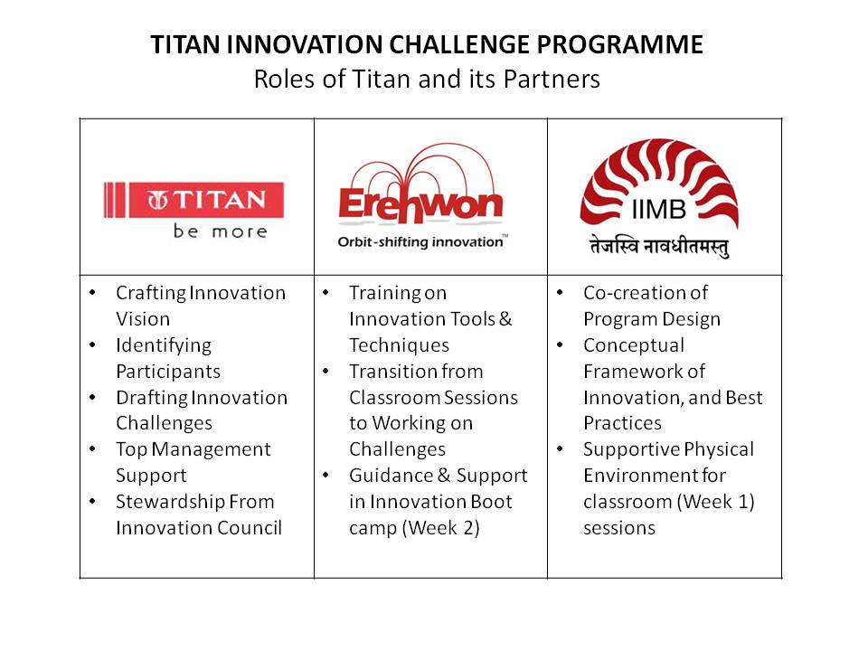
Conclusion
Tata Group has a strong history of leading by innovating in products, services, processes and business models. Titan Industry, the leading watches and jewellery brand in India, has itself been an innovation leader in the space. The Innovation Challenge Programme conducted with the intent of stimulating a culture of innovation has some useful insights to share. For such a programme to be successful, important success factors are: top leadership commitment, credible innovation champions, co-creation, well identified challenges, coaching on innovation tools and techniques, and involvement of an experienced innovation consultant. The results of the two week long challenge programme are yet to be seen in terms of how successfully the challenges are met, but the long terms measure is really about the impact such programme has on influencing a culture of innovation at the organizations.

Appendix-1
List of challenges identified for the Innovation Intervention:
- Increase the Plain-Jewellery Gross Margin by 2 Percentage
- Achieve 10 Fold Sales Jump for Brand Nebula
- Expand Titan Eye’s Footprint to 1,000 stores across India; &Achieving Customer Service in 5 minutes flat at Titan Eye
- Introduce Titan’s Personal Convenience Device
- Leverage Co-Creation for Innovation

Appendix- 2
Agenda for Week- I Programme at IIM Bangalore:
Context Setting
- Mr. Bhaskar Bhat, MD, Titan Industries.
Core Academic Sessions
- Basics of Management of Innovation, Prof. Rishikesha T Krishnan, Professor of Corporate Strategy & Policy, IIM Bangalore
- Building an Innovation Culture, Prof. Abhoy Ojha, Organizational Behaviour Area, IIMB
- Product Innovation, Prof. Rishikesha T Krishnan, Professor of Corporate Strategy & Policy, IIM Bangalore
- Business Model Innovation, Prof. DVR Seshadri, Professor of Marketing Management, IIM Bangalore
Guest Sessions: Motivation, Contextual Knowledge & Best Practices
- Innovation of Thought, Mr. R. Balki, Chairman, Lowe Lintas
- The Process of Innovation at Nokia &The importance of Agility in Product Innovation, Mr. D Shiv Kumar, MD, Nokia India
- The New Age Indian Consumer, Mr. Santosh Desai, MD&CEO, Future Brands Ltd
- Innovations in The Digital And Web World, Mr. Arun Tadanki, MD, Yahoo India
- Ethnography and Innovation: Industry examples, Ms.Apala Lahiri Chavan, Human Factors International
- Measurement of Innovation, Representative of Monitor Group (consulting firm)
Other Sessions
- Creative Problem Solving Techniques, Erehwon
- Achievements of Innovation School of Management @ Titan

Robert M. Grant Contemporary Strategic Management Sixth Edition Wiley-India, 2008.
Dorothy Leonard Wellsprings of Knowledge Harvard Business School Press, 1994.
Barry Jaruzelski and Kevin Dehoff, The Global Innovation 1000, Booz & Company, Issue 61, Winter 2010
Capitalizing on Complexity: IBM Global CEO Study 2010, IBM Institute of Business Value
See Venkat Ramaswamy & Francis Gouillart, The Power of Co-creation Free Press, 2010
James P Andrews, Measuring Innovation 2007, Boston Consulting Group, August 2007

