Systemic/holistic Management--Connecting the Dots with Project Monitoring 2.0
Supplement
Section 2. PROBLEM:
Synthetic vs. Analytic Thinking or Looking at the Interactions, not the Parts
The basic problem of today’s project management can be traced back to its legacies rooted in Management 1.0 analytical thinking, practices and theories. Contrary to popular belief, results cannot be managed solely by monitoring task completions and open issues because these are lagging factors. Therefore, managing the means rather than the ends seems fundamental. Furthermore, the ability to create those results in a coordinated, collaborative, and interactive way discriminates synthetic from analytic thinking or looking at the whole instead of the parts. Project monitoring 2.0 is a collaborative practice, an integrative real-time team game and no result driven controlling exercise.
In order to manage uncertainty and to remain agile and adaptive, a new way to managing the means is required in order to better achieve the ends. With people as the single most important factor, project monitoring as well as management has to be practiced as an integrative and holistic process in order to be able to connect all the dots involved. Therefore, Project Monitoring 2.0 is directed at managing the means rather than the ends.
Project management is basically a three step process aggregating planning (feed-forward), execution, and monitoring (feed-back). All three phases should share one fundamental principle – the management or control functions should not follow the command and control principles (Management 1.0) but should be made part of a collaborative social process (Management 2.0 principles). Therefore, Project Management 2.0 is practiced as a collaborative process directed at sharing and inclusion.

Section 3. SOLUTION:
The Research Background of the Six Box Leadership Model
The Six Box Leadership Model was developed through amalgamation and methodological and data triangulation of research findings from a number of research projects carried out by Professor Vlatka Hlupic (with various collaborators) over the period of more than 15 years.
These projects used various research methods, both qualitative and quantitative. Majority of these projects were interdisciplinary, investigating various aspects of value creation in organizations that lead to improved performance, innovation, resilience and engagement. As a result of these research projects, Professor Hlupic has published more than 150 articles in academic journals, books and conference proceedings.
Research projects that form a foundation of the Six Box Leadership Model involved both theoretical and empirical research. Theoretical research relates to a review of more than 1000 research articles, whilst empirical research is related to more than 23 case studies, involving more than 300 semi-structured interviews. Many of these case studies were in-depth, longitudinal case studies, carried out over the period of 2-3 years. Empirical research also involved a survey involving 88 organizations and more than 6000 respondents in a survey.
The findings from all these research projects informed the development of a holistic framework with more than 150 factors that drive value creation in organizations. These factors were grouped in six interconnected and interrelated areas that form the basis of the Six Box Leadership Model: Culture, Relationships, Individuals, Strategy, Systems and Resources. On the basis of these factors, an on-line questionnaire was developed to enable assessment of hidden strengths and bottlenecks in each of the six areas, and discovery of hidden dependencies and blockages to value creation. Addressing bottlenecks will lead to more value creation, improved performance, innovation and engagements and moving from Management 1.0 to Management 2.0.
Relationship between Project Monitoring 2.0, Collaborative Business Planning, and Using a Transparent Points System for Reward Management
Even though this work primarily focuses on monitoring and execution, it is worth to mention that in combination with collaborative business planning and performance incentives (covered elsewhere; please refer to hacks “Collaborative Business Planning” and Using a Transparent “Points System” for Reward Management), a powerful new Project Management 2.0 approach could be aggregated.
Even though this work primarily focuses on project monitoring, it is worth to mention that monitoring & facilitation is only one part to move to Project Management 2.0
- A complementary Management 2.0 incentive model is provided by the Using transparent "points system" for reward management hack
- A complementary Management 2.0 collaborative business planning model is provided by the “Collaborative Business Planning” hack
Taken together, the three hacks provide a sound basis for a Project Management 2.0 approach covering the aspects of efficiency (monitoring & facilitation), effectiveness (collaborative business planning), and development (monitoring & facilitation, incentives).
In the given context, the Six Box Leadership Model is used as a blueprint to derive a systemic set of questions required as information input of all project participants. Hlupic’s research base serves as an empirical reference to identify the gaps between desirable and actual behaviors or conditions. In a third step, those gaps are addressed and attacked through a collaborative and facilitated group process including all project members, stakeholders, and sponsors.
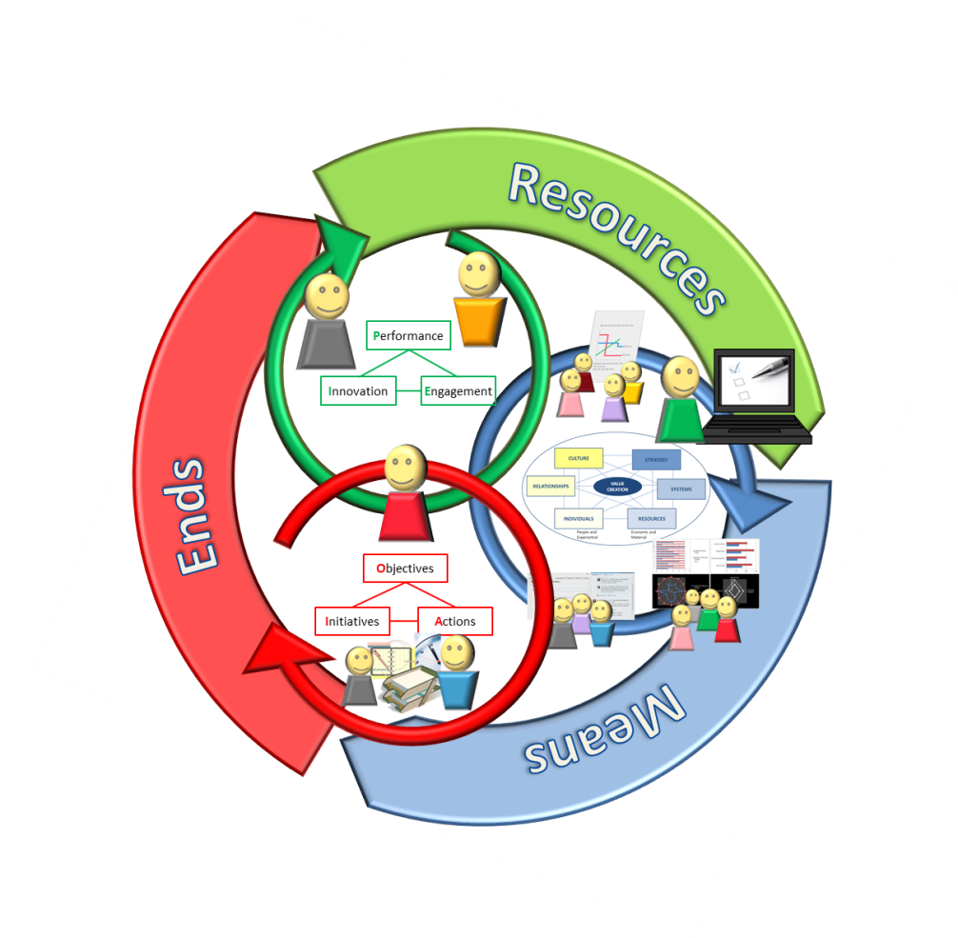
Figure 1: Project Management 2.0 – Combining “Collaborative Business Planning,” “Transparent Points System,” and “Project Monitoring 2.0”
Functional and Non-functional Requirements of Project Monitoring 2.0
- Questionnaire: Design of a questionnaire based on the empirical key success factors taken from Hlupic’s Six Box Leadership research (see below) by utilizing a 5 Point Likert scale; the questionnaire serves as the input basis for project team members and stakeholders alike; the time required for answering shall not exceed 2 minutes, hence the number of questions should be limited to 12 at max.
The following groups of factors that drive value creation are part of the six boxes of the “Six Box Leadership Model” (there are 150 individual factors contained in these groups of factors) :
People and Environmental
- CULTURE
- Democracy
- Motivation
- Trust and Transparency
- Values and Vision
- Unique Factors
- RELATIONSHIPS
- Co-operation
- Good communication
- Team building
- Type and quality of interaction
- INDIVIDUALS
- Attitude and Mindset
- Cognitive
- Self Development
- Skills
Economic and Material
- STRATEGY
- External Environment
- Goals and Targets
- Objectives
- Risk Appetite
- SYSTEMS
- Emergence
- Organizational Learning
- Processes
- Structure
- RESOURCES
- Cash
- Contracts
- Information
- Intellectual Property Rights
- Physical Assets and IT Infrastructure
There are 110 questions in the Six Box Leadership survey (developed on the basis of 150 factors), and we have selected and adapted the following 12 questions for Project Monitoring 2.0:
People and Environmental
- Dimension: Culture
- Trust is part of our culture
- The Interests of our customers and suppliers are important to us
- Dimension: Relationships
- The work with all stakeholders is collaborative
- Knowledge and information is shared freely
- Dimension: Individuals
- People form strong networks
- We share common values to achieve our objectives
Economic and Material
- Dimension: Strategy
- Business information management is aligned with strategy
- The majority of people know our objectives
- Dimension: Systems
- Business information systems support processes
- We use Knowledge Management systems as a support for achieving our objectives
- Dimension: Resources
- People share resources across organizational boundaries
- We have all the resources we need to achieve our objectives
First Pass
- Questionnaire (Input): Setting up an Excel questionnaire for each project member’s and stakeholders’ individual input. The questions are derived from the logic and are composed according the empirical foundation of the Six Box Leadership Model.
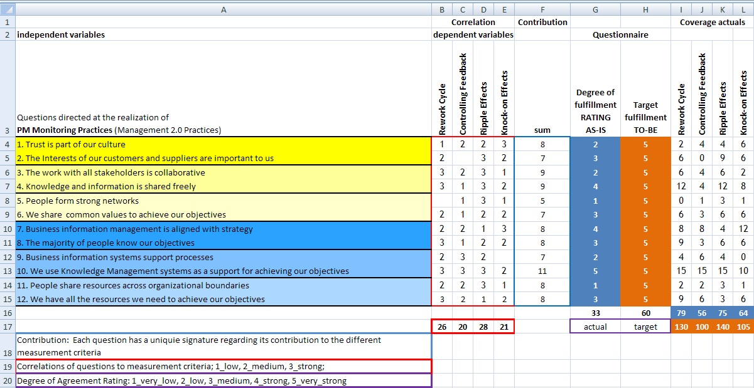
Figure 2: Example: Excel-based Six Box Leadership Model questionnaire including the aggregation schemes

- Dashboard (Output): The aggregated real-time monitoring is realized via an Excel Diagram available to all project members. All individual input data (Questionnaire Input) is calculated by using a Excel diagram sheet containing different graphical representations along the 6 Box coverage and numbered question dimensions. The dashboard sheet is updated on a daily basis.
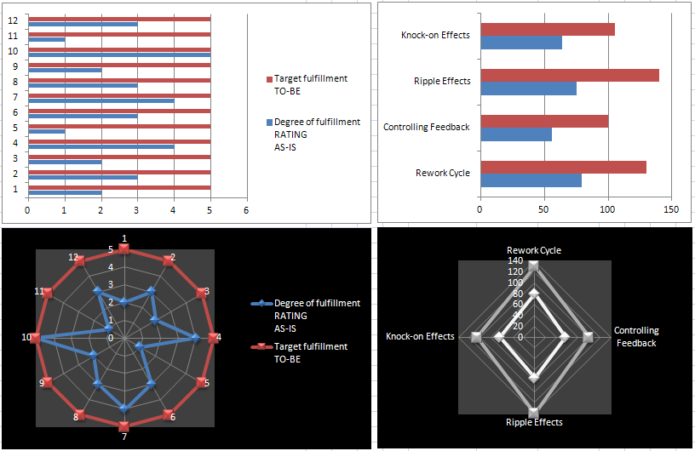
Figure 3: Example of Excel-based Dashboard Diagrams

- Project-Folder: The individual Excel questionnaires as well as the Excel diagram (report) are hosted in the project folder on a file server. The individual Excel questionnaires have to be kept private (confidential) and are hence only accessible by the individual project members. The Excel Diagrams (reports) are public and hence have to be accessible to all project members.
- Collaborative Platform: A collaborative platform has to be set up in order to enable collaborative planning and communication.
Second Pass
- Questionnaire (Input): The Excel questionnaire format is replaced by a web-based version.
- Dashboard (Output): The Excel diagrams are replaces by a web-based dashboard solution.
- Project-Folder and Collaborative Platform: The project folder and collaborative platform are integrated by using cloud technology, a SharePoint server or something similar.
Third Pass
- Questionnaire (Input) and Dashboard (Output): Web-based input and output services are extended by utilizing mobile devices (iPhone, iPad or something similar). BI technology is provided to extend the functionality from information aggregation to trend-over-time processing and applying analytical intelligence services on the input data.
- Collaborative Platform: Collaboration is further improved through the utilization of mobile devices (Blackberry, iPhone, iPad or something similar).
Seciton 4. PRACTICAL IMPACT:
Transcending Management 1.0 Paradigms through Project Monitoring 2.0
The best way to describe how Project Monitoring 2.0 works in practice is to outline how it implements Management 2.0 principles.
- Openness - The willingness to share information and do business out in the open
No problems or solutions can be entertained free of their context; openness is realized through the wisdom and justification of many people and hence by utilizing many different perspectives embedded within different context or realities (different functions, departments, teams, levels, cultures etc.).
- Community - The ability for people with shared purpose to organize and engage
Self-organization and shared purpose are engaged and propelled through collectively gaining a big picture from the first day on and having the participative power to optimize the project or group’s behaviors as a whole in the eyes of others (groups, teams, functions, senior management etc.).
- Meritocracy - An environment where ideas and people succeed based on the quality of their ideas and contributions
By distributing the positional control from the top to the teams, control becomes a function of collective knowledge, understanding, and wisdom. Inherited power is replaced by collective contribution.
- Activism - Tapping into individuals' desire to stand up, opt in, and express themselves
Knowing where you stand at any time is a precondition to timely correction and hence the application of corrective behaviors. In that, retrospective reporting is worthless for activism because I cannot react today if I know about a change requirement on tomorrow.
- Collaboration - The capability of groups of people to work together, divide tasks, and leverage individual strengths
Collaboration is strongly supported by monitoring the individual feedbacks of others instead of conducting satisfaction surveys at the end of the project or waiting for bad results until it is too late. Real-time behavioral monitoring enables anyone to test own behaviors or to know about someone else’s strengths by getting feedback nearly immediately and from anywhere.
- Meaning - The most powerful motivations come from within
In contrast to conventional monitoring and reporting, real-time visibility with a shifted focus from pure results to a holistic system view makes it possible to understand where you stand. Nothing is more relevant to people than to know how they are perceived by others – this has real meaning to anybody, hasn’t it?
- Autonomy - The freedom to act on one’s own, making decisions without direction or approval from higher levels of management
It is up to each project participant to improve own behaviors, contributions, or performance if not compliant with the agreed upon criteria (questionnaire results) and standards - no one has to be asked, no one other can do it for you, it’s only up to you!
- Serendipity - The occurrence of events by chance in a beneficial way has always played a fundamental role in innovation
Holistic real-time monitoring is the most potent sensory system a project can have!
- Decentralization - Rather than a top-down approach where activity and decision-making are closely held in small, central areas—decentralization allows it to happen anywhere
Responsibility is with the individual project member! With the project manager’s role changed from a controller and administrator to a facilitator and the employees and stakeholders as accountable individuals for the overall project success (shifting from pure results to collaboration/interaction focus), controlling power is distributed within the system rather than enforced top-down.
- Experimentation - An environment where ideas can be tested quickly and improved continually
Real-time information enables experimentation regarding what works and what doesn’t - on a daily basis and by providing daily feedback.
- Speed - The unprecedented pace of change and immediacy of information
Real-time information exchange is a core principle of the proposed approach.
- Trust - An acknowledgement that each of us is acting on good faith and good work will be reciprocated
Trust means the security of action in the situation of uncertainty. Justified trust needs to be checked and controlled. The assurance and reassurance of agreements is essential to know where you stand and is best utilized through real-time feedback provided by those affected by your behaviors and actions.

Section 6. EXPERIMENTAL APPROACH:
Project Management 2.0 Measurement Criteria
Based on the notion of differentiating Means & Ends with means being the leading indicators for achieving ends (lagging indicators), the final effectiveness of managing the value drivers identified through collaborative feedback on the Six Box Leadership Model questions (means) has finally to be quantified according to project specific measures (ends).
Measurement criteria are built upon the Systems Dynamic model of Lyneis and Ford. These measurement criteria are suited to cover unintended consequences of perceptional gaps (Rework Cycle, Controlling Feedback) as well as Ripple Effects and Knock-on Effects which are internal to the project (including suppliers, subcontractors, and stakeholder contribution). Furthermore, adverse feedbacks of clients and customers can initiate or amplify internal project dynamics which are subsumed by measuring external in combination with internal effects.
Managing the Means to Achieve the Desired Ends
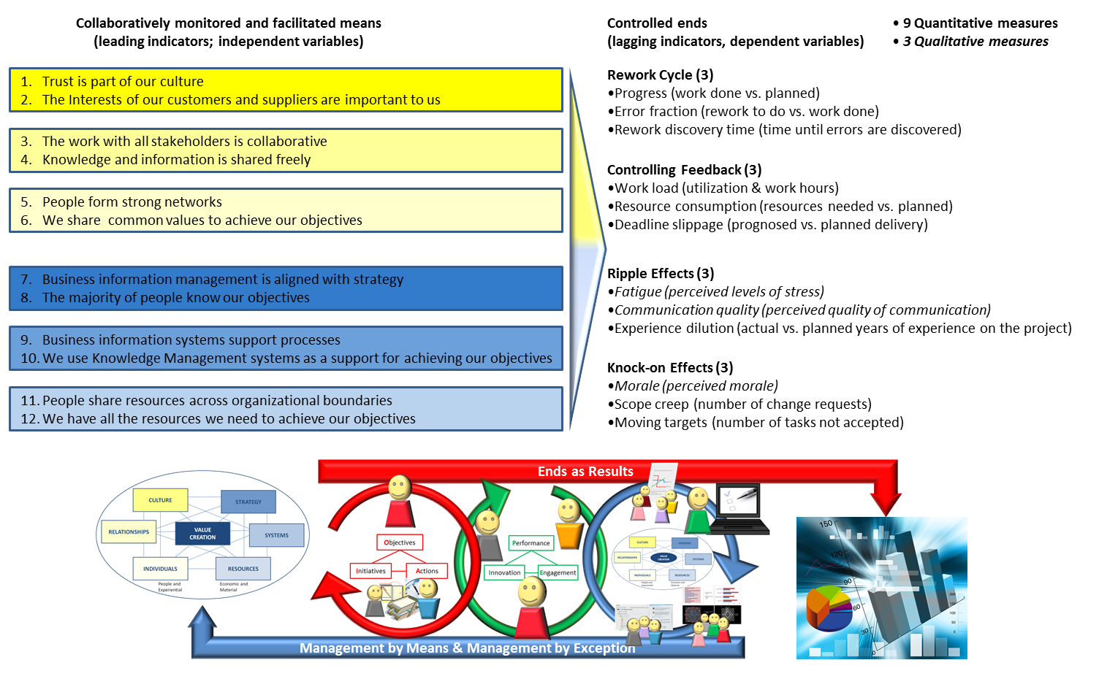
Figure 4: Means Monitoring and Ends Controlling

Examples of academic publications that illustrate research background behind Six Box Leadership Model include: - Amar D. Amar, Carsten Hentrich and Vlatka Hlupic: “To Be a Better Leader, Give up Authority”, Harvard Business Review, 87(12), pp.22-24, December 2009 issue, ISSN 0017-8012. Received the Bright Idea Award in Management of New Jersey Policy Research Organization (NJPRO) Foundation. - Amar D. Amar, Carsten Hentrich, Bami Bastani, Vlatka Hlupic: “How Managers Succeed by Letting Employees Lead”, Organizational Dynamics, invited seminal paper forthcoming in 2012, 47;1, ISSN 0090-2616. - Sajda Qureshi, Bob Briggs and Vlatka Hlupic: “Value Creation from Intellectual Capital: Convergence of Knowledge Management and Collaboration in the Intellectual Bandwidth Model”, Journal of Group Decision and Negotiation, special issue on “Current Advances in Collaboration Process Support”, 15(3), pp.197-220, 2006, ISSN:0926-2644. - Vlatka Hlupic, Gert-Jan de Vreede and Alessandra Orsoni: “Modelling and Simulation Techniques for Business Process Analysis and Re-Engineering”, International Journal of Simulation Systems Science and Technology, Vol 7 (4-5), pp 1-8, 2006, ISSN:1473-8031. - Vlatka Hlupic, Anasthasia Pouloudi and George Rzevski: “Towards an integrated approach to Knowledge Management: 'hard', 'soft' and 'abstract' issues”, Knowledge and Process Management, the Journal of Corporate Transformation, 9(0), pp.1-14, 2002, ISSN: 1092-4604. - Jyoti Choudrie, Vlatka Hlupic and Zahir Irani: "Teams and Their Motivation for Business Process Re-engineering", International Journal of Flexible Manufacturing Systems, 14, pp. 45-52, 2002, ISSN: 0920-6299.
Please refer to the Management 2.0 Hackathon hack “Collaborative Business Planning” by Matt Johnson or visit the Omnistrat© website www.omnistrat.com
Please refer to Management 2.0 Hackathon hack “Using transparent "points system" for reward management”
See Ackoff, Russell: "Re-Creating the Corporation: A Design of Organizations for the 21st Century," A Design of Organizations for the 21st Century, Oxford University Press, USA, 1999
Ibid: page 161 ff. – see Fig. 1. The rework cycle (adapted from Cooper, 1993); Fig. 2. Controlling feedback loops for achieving a target schedule (deadline); Fig. 3. Policy resistance via ripple effects of rework and controlling feedback to improve schedule performance
Ibid: page 159 - "Ripple effects" is the name commonly used in projects to describe the primary side effects of well-intentioned project control efforts. Modeling ripple effects in projects captures and leverages the concept of policy resistance.
Ibid: page 159 - "Knock-on effects" refers to the secondary impacts of project control efforts, i.e., the impacts of ripple effects, often caused by processes that produce excessive or detrimental concurrence or human factors that amplify the negative effects via channels such as morale.
Ibid: page 166

